INTRODUCTION
This was to have been a little pamphlet showing the descent of me - Christopher John Alfred Dixon, and I had intentions to trace both the male line (Dixon) and the female line (Elkington) of my paternal grandparents. It was my grandmother, Gertrude DIXON (nee Elkington) who, years ago, when I was not yet a teenager, kindled my interest in family history. She showed me the deeds to a little cottage in Layer Breton, and although I didn't understand the wording I was fascinated by the feel of the parchment, the legal jargon and the calligraphy of the eighteenth and nineteenth centuries. From then on, I wanted to know where we came from and what our roots were.
I started on the genealogical trail in 1972, when I was working for the National Westminster Bank in London. I was only going to trace the Dixon and Elkington line. Regarding the Dixon line I progressed fairly quickly to Isaac but thereafter I hit bedrock. Where Isaac came from and what his life was like I haven't been able to find out. However, after making contact with my New Zealand Dixon relatives, more information came to light about Isaac – but not where he came from.
One good thing I discovered early in my search, was how interested people became when I explained my quest, but the best thing of all is when you discover you have distant cousins that you had only heard stories about, or who up to that moment were only rumours. I had lived for some time around the Colchester/Ipswich regions and never known there were at least 50 fairly close relatives in the same area (the DENNIS family). And at least 100 in the Mexborough, South Yorkshire area. And my uncle(s) Dennis living less than 5 miles from the place of my birth!! Having met some of this new family I researched them and solved the mystery of why the name Cheveley still appears in their family. In solving that problem, I stumbled upon a whole new family to research, and although, in the strictest sense I cannot claim them as my own - the fun of research and the sense of bringing our English history to life compelled me to go on. All of this was brought about by my Aunt Phyllis (Burns) introducing me to my uncle(s) Dennis - Cheveley and Patrick & their sister Audrey Davey. I have written family history books on these families.
These families were, without doubt, from that solid backbone of English life - the yeoman stock. In our veins flows the blood of farmers, soldiers, sailors and shopkeepers. We may not have contributed greatly to individual incidents in history, or hobnobbed with kings and queens but our ancestors helped to make Britain great.
To my family I give this booklet. You know now where your roots lie, but it is my fervent hope that one of you, in the future, will continue the research and find what I failed to find.
Good Luck!! Christopher John Alfred Dixon 2023.
ACKNOWLEDGEMENTS

Gertrude Anne Elkington, my grandmother without whom none of this would have been possible; my parents Alfred Patrick John Dixon & Marion Edna Dixon (nee Evans) for their unfailing support; my wife, Pamela Lesley Dixon (nee Smith) for her patience & help in sifting through records and combing the churchyards at night with a torch to see the faint scratchings on the gravestones; to my Aunt Phyl(lis) Burns (nee Dixon) for her unstinting help, advice, proofreading and for supplying many of the photographs as well as undertaking research for me; my Aunt Nora McKay (nee Dixon) for information on Alfred James and on the Dennis family; to Cheveley and Pat Dennis, Marianna Dennis and Audrey Davey for getting me started on the Dennis line and correcting mistakes; to Jack Cheveley Rickett for showing me another branch of the Dennis line and to Pat Waters for supplying all the photographs in the Dennis chapter and at her own cost, as well as much invaluable help with the other branches of the Dennis family; to Cyril Smith and Lillian Smith (nee Sexton).
Grateful thanks also to R.D. Cheveley for help with the Cheveley family tree, the proprietors of the Railway Inn at Ponders End for giving me the photographs and certificate of Alfred James, to Tony Nicholls of Marks Tey near Colchester for reproducing some of the photographs shown in this booklet at cost price, and to Peter Jeremy Dixon for reproducing most of the rest; to Mr & Mrs House of Cossey for allowing me to roam over the remains of Cossey Hall, to the Society of Genealogists, the Essex Record.
And lastly, because they are the very last Dixon family that I have found (or rather, they found me), my New Zealand cousins. The children of Isaac Dixon, for many years, was just a blank on the family tree. He emigrated to New Zealand and I was lucky enough to meet Isaac Dixon before he passed away in 2014. Thanks to him, Grant and Cathy for the huge volume of material that I now have access to.
The logical place to start is at the beginning, and there are two ways in which I can go - from the earliest person onwards or the latest backwards. In this story I have opted for the traditional approach - from the first to the last.
During the course of this research I have sometimes referred in the texts to the principal characters by their first 2 names or by an abbreviation ie AJ is short for Alfred John, AA means Alfred Archer. This is because, after Isaac, the next 4 Dixons all bore the same first name - Alfred John, Alfred Archer, Alfred James and Alfred Patrick John. I carry the name Alfred as a third name, and my son too, continues the tradition - it is his third name, James Trevor Alfred Dixon.
Many of the people I have mentioned have passed on. This is their legacy.
Introduction
The story opens in 1770, or thereabouts at the birth of Isaac Dixon in Welling, Kent. It took me 25 years to find where he came from – East Wickham in Kent. Why he moved to Harrow-on-the-Hill is unknown. In East Wickham he was listed as a beer housekeeper. He married Ann Elvee.
Thanks to the internet and DNA testing, I found, to my delight, that I have cousins in New Zealand, the descendants of one of Isaac’s children. Their research brought a whole new picture to where Isaac came from
Known facts about Isaac Dixon.
School of thought 1 (mine and the NZ family). All the records (census, marriage and death certificate) suggest he was born in 1770. There is no evidence for anything else …. and I do like evidence.  Isaac had the lease of a substantial piece of property in Rochester, Kent. Where did he get the stake for it? Was it a gift from a relative? We know he was not honest when he was in the Excise because he was fired.  He was a publican/farmer. Selling alcohol runs in the family. Was he related to the Dixon licensed victuallers in the area? I don't believe the conjecture of Richard Ellender.  There are some really silly assumptions some people make about Isaac's family out there in the online trees | School of thought 2: The NZ branch of the family employed a genealogist by the name of Richard Ellender in 1991 who advised that Isaac was born 1780 and his parents were John Dixon of Staple who married Mary Tyler of Ash in 1777.  Cathy Dixon in NZ did more research and believes that Mary Tyler of Ash in fact married John Burton of Staple (not John Dixon) in 1777. She has seen the Staple parish records and there can be no mistaking that it does read John Burton and they have various children together (none named Isaac).  Richard Ellender (who has passed away), was certain at the time that this John Dixon, who married Mary Tyler of Ash, was the only John Dixon who fathered an Isaac Dixon in the whole second half of the 18th century in a twenty-mile radius around Canterbury. BUT THERE ARE NO RECORDS! They could have been lost of course. He assumed it was the right connection. And we all know what ASSUME stands for  Richard is no longer alive and his claims are unable to be verified. But you will find family trees on the net claiming his findings to be fact.

Dear readers ... I leave it up to you to decide. Beware false prophets. The proof is in the pudding, or in this case the records and DNA. There are some gullible people out there.

Chapter One Gen 1: Isaac Dixon
The story opens in 1770, or thereabouts at the birth of Isaac DIXON. There is some speculation as to his actual birth date, because his death certificate states he was 77 when he died, thereby giving him a birthdate of circa 1770.
We know nothing of Isaac in his formative years - from when he would have joined the workforce to his entry into the excise service. What was happening in these days? King George III was on the throne. There was a lot happening! There are records of a Corporal Isaac Dixon being a prisoner of the French and being exchanged on 12 Nov 1798.
1786 Captain Arthur Phillip leaves Portsmouth with the eleven ships of the First Fleet carrying around 700 convicts and at least 300 crew and guards to establish a penal colony in Australia.; The original Lord's Cricket Ground holds its first cricket match
1788 First bout of madness for King George III
1789 Fletcher Christian leads a mutiny on HMS Bounty against Captain William Bligh in Polynesia
1789 onwards - canals start being opened up
1791 The first issue of The Observer, the world's first Sunday newspaper, is published
1793 start of French Revolutionary Wars
The picture of Isaac of Isaac Dixon on the front cover of this booklet and below has been in the possession of the Hawke's Bay NZ Dixon family (who emigrated to NZ in 1890). They were told it was of Isaac as a young man. I sent a digital copy to the Victoria & Albert Museum in 2016 and this is the reply: "Based on your attached image, it appears to be a photographic portrait from the mid to late nineteenth-century, and not a photograph of a painting. However, that is just from looking at the .jpeg file, and it is hard to make any confident assertions without physically witnessing the object." The original photo is out there somewhere - we hope.
Isaac’s first appearance in the records is when he was issued a license to sell beers and spirits. I had some research done a few years ago by Gillian Rickard - she checked the Registers of Alehouse Recognizances for Kent and discovered Isaac was a licensed alehouse keeper from September 1798 to 1816. So he was 28 when he became a publican. Did his license cover the pub that he later held the license - the Guy Earl of Warwick pub in Bexley, Kent?
I am grateful to Penny Duggan Secretary, Bexley Historical Society who stated in 2016 that "the present Guy Earl of Warwick was built in 1926. The old pub, which was demolished, stood west of the present building on part of the site of John Newton Court (housing). Licences for it can be traced back to 1730. The pub was enlarged in 1792. Adjacent to this pub was the equally ancient Hope Lodge which became a private school. When that moved, around 1800, the buildings and pleasure gardens were merged with the pub."
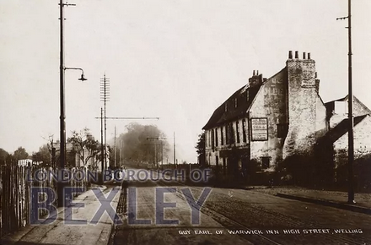 | 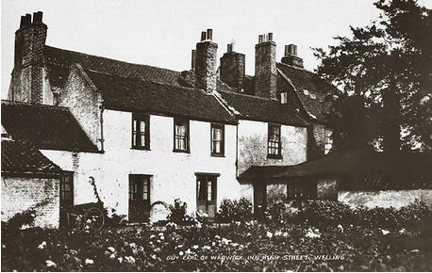
Guy Earl of Warwick c 1890 | Back of the Guy Earl of Warwick c 1890
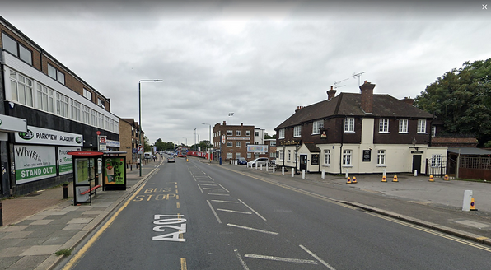 |  | 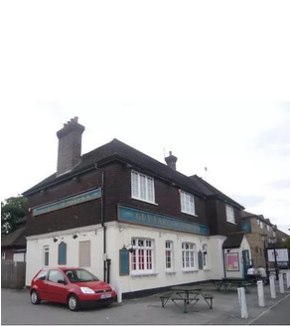
same position 2022 | Guy Earl of Warwick c 2022

Isaac Dixon married Ann Elvy on the 8 November 1803 at St Nicholas Church, Rochester, Kent. Ann was the daughter of Robert Elvee and Jane Cook. Robert was a Freeman of Rochester and we know that Ann had a sister, Mary Eliza Elvee bc 1788. Ann Elvee was baptised 7 March 1781 in Chatham, Kent. Why did they get married by license instead of in a church? "There have always been some people who want to marry in a hurry or in private. The church allowed them to avoid the delay and publicity of calling banns on three successive Sundays by providing, for a fee, a marriage license. The information given in order to obtain the license may include detail not available elsewhere. The centrally filed record may lead directly to the place of marriage and may survive when the marriage record itself has been lost.”
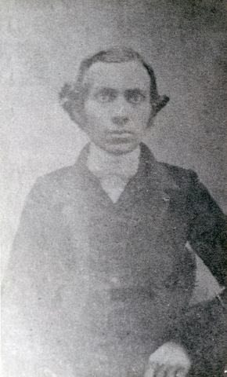 | 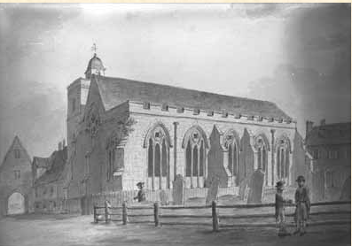
 | Above: St Nicholas Church, Rochester from a painting c 1807. Below: The church in 2022. Originally dating from 1421-3, the present building largely dates from 1621. De-consecrated in the 1960's, it now serves as the Diocesan Office for the Diocese of Rochester.
 | 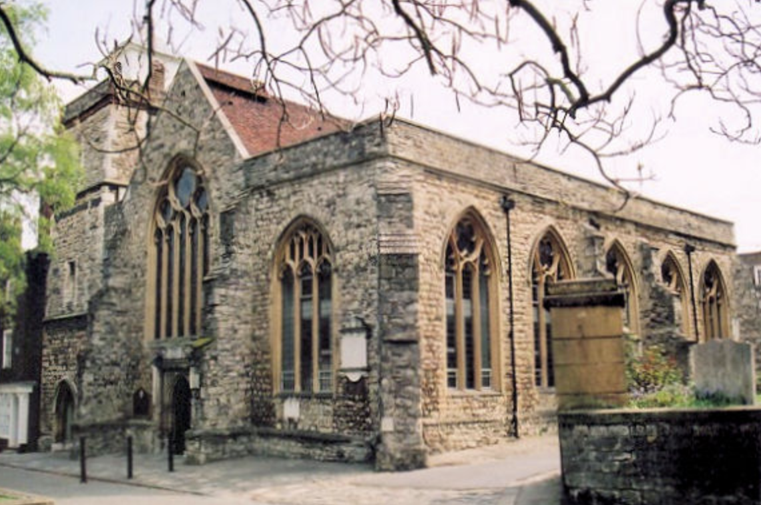

After their marriage Isaac and Ann moved to Elham in Kent. Recent research by Julia of Acorn Family History Research has uncovered that Isaac was employed as an excise officer. There's quite a lot of information about the role of an excise officer and it can be found in this e-book "The excise officer's manual, and improved gauger : being a compendious introduction to the business of charging and collecting the duties of excise" by Joseph Bateman.

Julia reports "The fact that Isaac ran the pub is perhaps not coincidental when viewed in the light of what I discovered today on my trip to The National Archives. I was able to follow Isaac's career as an Excise Officer through the records - unfortunately I did not find his original appointment, but I found that before he was in Canterbury he was working in the Elham area, Elham being a village between Canterbury and Folkestone. From Canterbury he transferred to the Romney area, the dates coinciding with his marriage and his move to that area. His career with the Excise came to an unfortunate end in 1806 when he was discharged for malpractice to do with encouraging those on his 'round' to order alcoholic liquor from a particular dealer. This, together with him having been given notice to quit, was presumably the reason for his move away from Romney to Bexley.”
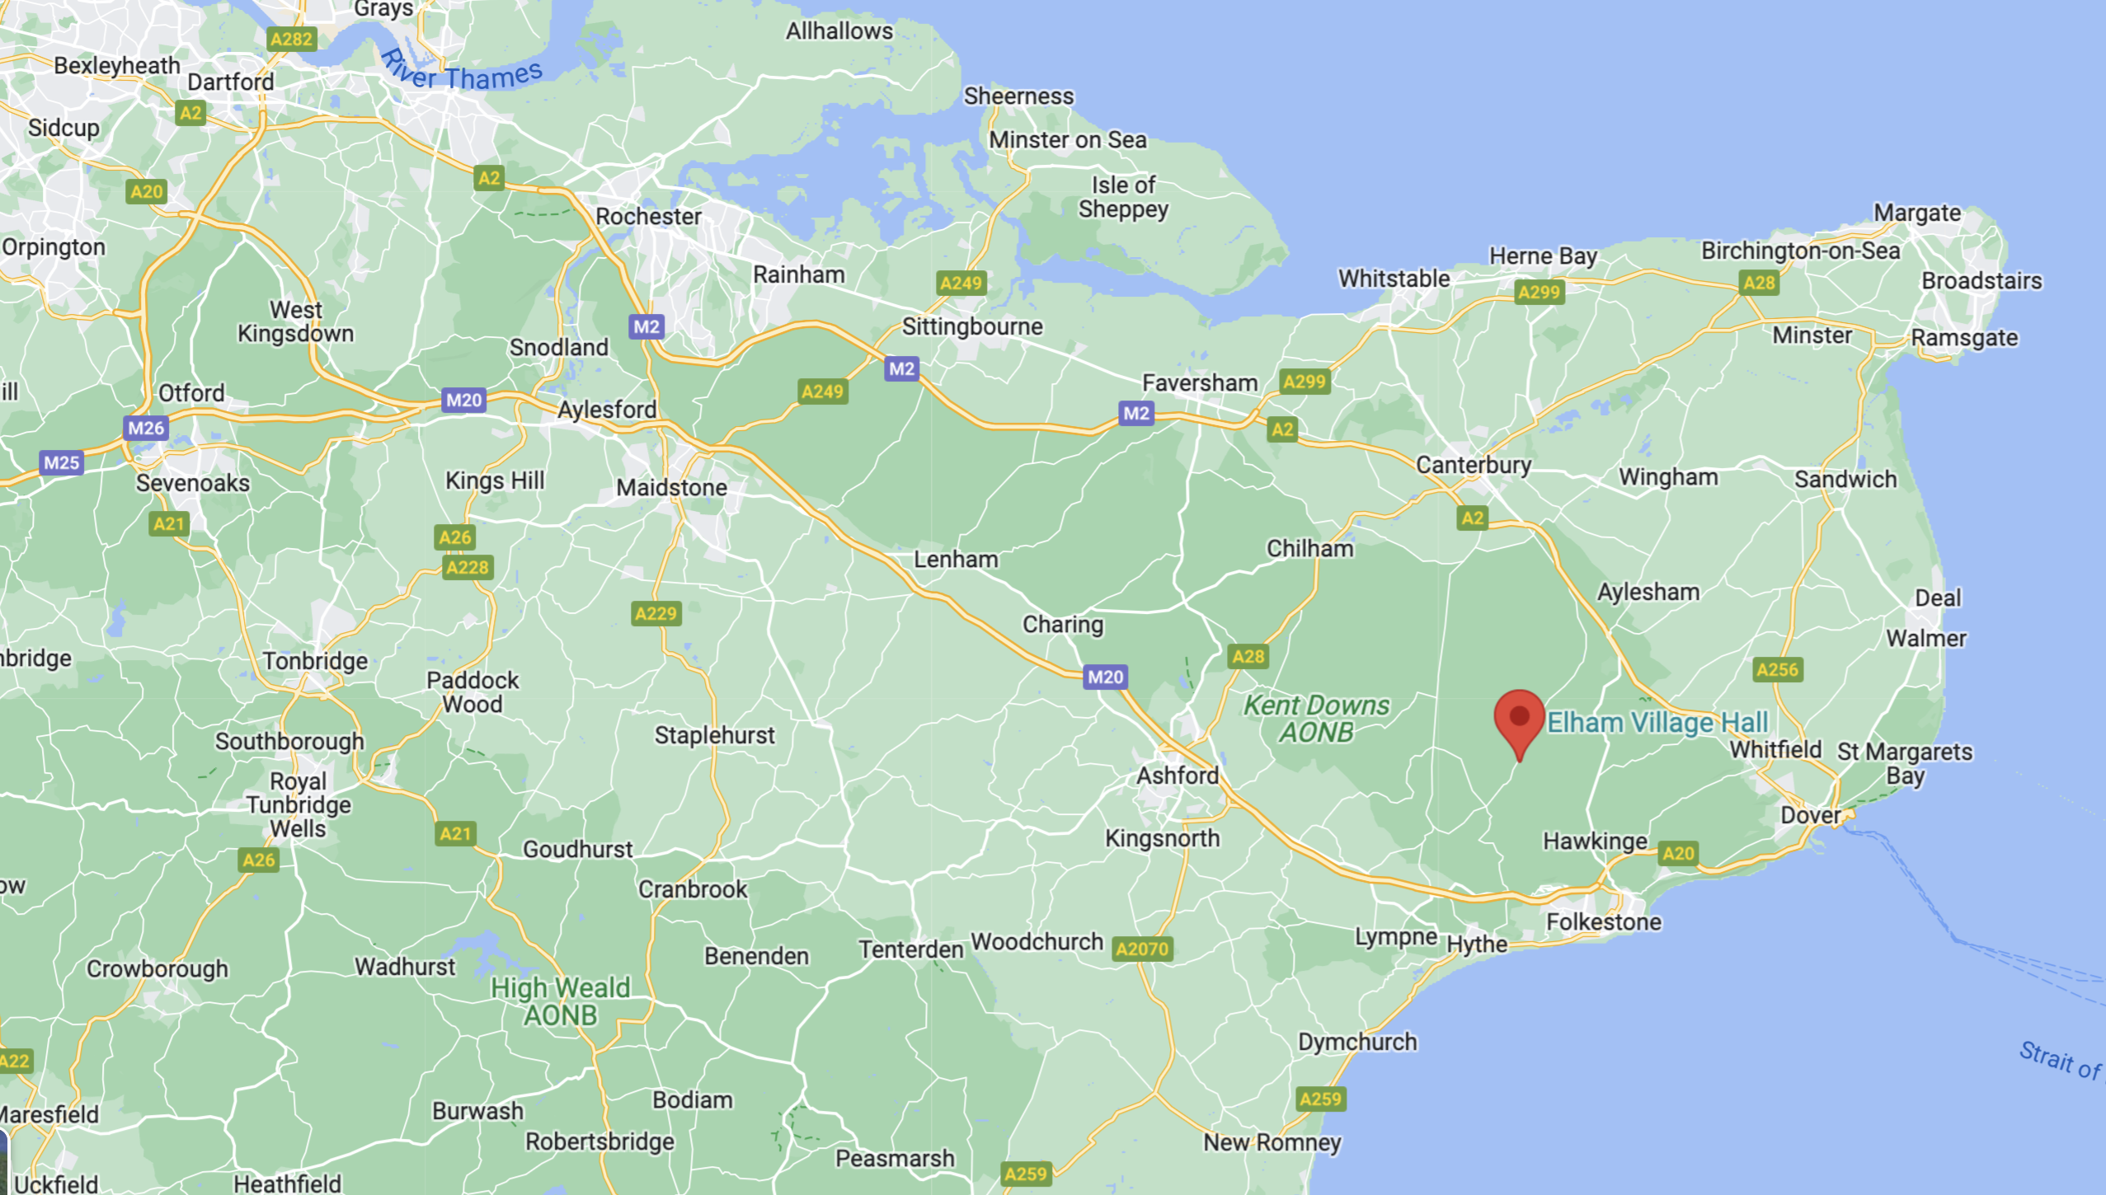

So, Isaac was an excise officer - first in Elham (one of the most beautiful villages in England), then Canterbury and finally in New Romney. In New Romney, Ann had given birth and lost two children who both died on the same day just a few days before Christmas - how heartbreaking. I believe that they died of malaria. "From 1564 the health of the marsh population suffered from malaria, then known as ague or marsh fever, which caused high mortality rates." Wikipedia.
It was a very unhealthy place to live. “Romney Marsh in the 17th and 18th centuries was known for its high prevalence of disease and death. Mortality in the marshes was exceptionally high, with rates of infant mortality some two to three times higher than in neighbouring parishes. The marshes, like many other parts of early modern England, were afflicted with a range of infectious and chronic diseases. Bubonic plague, smallpox and fevers all took their toll. The marshes, moreover, suffered from the additional problem of malaria. Most deaths were caused by malaria. Malaria receded slowly from the marshes and by the mid- 19th century Romney Marsh was one of the healthiest districts of Kent.” Which is little comfort for Isaac and Ann.
Isaac was very busy tracking down smugglers and charging excise duty for the government. It was only a short distance to France and smugglers could earn a lot of money by “wool-running”. Wool-running was the export of wool to France without paying the export duty. It was very profitable for the smugglers, who exchanged the wool for brandy, wine and spirits. A farm labourer at that time could earn about 17 pennies a day (£17 a day in 2022), while a smuggler could earn about ten shillings (£120 a day in 2022).
“The smugglers and lookers of marshland communities were invariably described as mean, stupid, apathetic, caring little whether they lived or died. The parish of St Mary-in-the-Marsh was a typical example inhabited by 'not above 50 persons, all of mean quality, marsh lookers', and at Dymchurch the inhabitants 'are of the lower sort, and, like others dwelling in the rest of the Marsh, are mostly such as are employed in the occupations and management of the level, or a kind of seafaring men, who follow an illicit trade, as well by land as water.”
Isaac was either a customs officer or a riding officer. “The principal duty of the riding officer was to patrol the coast within their predefined riding range to suppress smuggling. Their duties included meeting and corresponding with the other riding officers either in person or by letter and inquiring and learning if there were any smuggled goods upon the coast, or landed. They were to get the best information regarding this booty, and to acquaint the Officers of the Customs all over the shire. The Riding Officer always kept a journal reporting all his activities.”
A Riding Officer was paid between £20 - £40 a year (£1700-3500 in 2022) and was forbidden to take fees or gratuities. He was also expected to buy, care for, and accommodate his own horse. He was appointed by a constitution of the Treasury and had a deputation from the Commissioner of Customs and Excise. He took the oaths of office and gave bond and security. He received printed instructions for his conduct with his deputation. He endeavoured to get information as to any illicit practices and makes seizures whenever he could. It was an extremely dangerous job and often resulted in the officer being severely beaten and often murdered. Daniel Carter, a Custom house officer was murdered. “The seven miscreants of the lowest kind were hanged at Chichester 18 Jan 1749. Their dead bodies were hung in chains for the delectation of the fowls of the air at Rake, at Selsey Bill, and at Rook’s Hill near Chichester.”
So the Riding Officer was cold, wet, outgunned and poorly paid and in essence, useless. In his annual report in 1783, Sir William Musgrave, the Commissioner of Customs and Excise, said that Riding Officers were 'of very little service, 'tho' a great Burthen to the Revenue'.
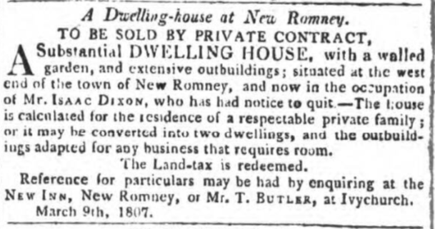
Following Isaac’s nefarious activities at bending the rules of the Excise department he was dismissed from the service. We find that in the spring of 1807 there is an advert in the Times of London for the sale of his house which he rented. You can imagine Ann insisting that they go back home to Bexley, a much cleaner environment.
And thus a new chapter in the life of Isaac and Ann commences.
​What was Isaac doing in Bexley? Well, we know he held a 21-year lease for the Guy, Earl of Warwick in Welling - now Bexley Heath. And he had held that license since 1798. The Guy, Earl of Warwick was a popular coaching inn on the old Roman road to Canterbury. But towards the end of 1815, things were not going so well for Isaac - he was going bankrupt. His name appears in the press fairly frequently.
Was Isaac a bad publican or were there other factors at work? 200 years ago, our ancestors experienced a year without a summer. They had their own climate change disaster. 1816 became the year without a summer for millions of people in parts of North America and Europe, leading to failed crops and near-famine conditions. While they didn't know the chill's cause at the time, scientists and historians now know that the biggest volcanic eruption in human history, on the other side of the world — Mount Tambora in Indonesia in April 1815 — spewed millions of tons of dust, ash and sulphur dioxide into the atmosphere, temporarily changing the world's climate and dropping global temperatures by as much as 3 degrees. The gloom spread to the literary world, too: that foul, frigid year inspired the plot of Mary Shelly's epic horror novel Frankenstein. Crops failed, so Isaac would have been unable to obtain barley for the beer, the country relied on farm workers and most of them were out of work.
" The Commissioners in a Commission of Bankruptcy bearing date the 30th day of May 1816, awarded and issued forth against Isaac Dixon, of Welling, Kent, in the Parish of Bexley in the County of Kent, Innkeeper, Dealer and Chapman". "The Commissioners in a Commission of Bankruptcy bearing date the 30th day of May 1816, awarded and issued forth against Isaac Dixon, of Welling, Kent, in the Parish of Bexley in the County of Kent, Innkeeper, Dealer and Chapman, intend to meet on the 18th of April next, at Eleven of the Clock in the Forenoon at Guildhall, London, to make a Dividend of the Estate and Effects of the said Bankrupt; when and where the Creditors, who have not already proved their Debts, are to come prepared to prove the same, or they will be excluded the Benefit of the said Dividend. And all Claims not then proved will be disallowed."
The Times of London 10 Aug 1816 describes it quite comprehensively. I have reproduced the article below – seems the journalist wasn’t keen on full stops: "Welling, Kent – To Brewers, Stage-coach and post-masters – By T STRONG, on the Premises, on Thursday, Aug 22, at two precisely, by order of the Assignees of Mr Isaac Dixon, the valuable LEASE, for 21 years from Michaelmas 1816 of that old-established, well-known, and accustomed INN the Guy Earl of Warwick, situate at Welling, only 10 miles from London, on the high road to Dover, the first regular stage from London and a number of stage-coaches change horses daily, excellent stabling, yard, extensive and beautiful gardens stocked with abundance of the choicest fruit trees, fish-pond stored with fish, and several enclosures of exceeding rich land, containing, more or less, the whole lying within a ring fence, and taken as a whole, has scarcely its parallel. At the same time will be sold, the Lease, 4 years of which will be unexpired at Michaelmas next, of a large yard, stabling for 20 horses, barn and granary, and 2 acres of good land, subject to a very low rent, opposite the above; also the Lease for a term of years, at a low rent, of 11 acres, more or less, of very rich land, lately cultivated and improved at an immense expense, situate on the high road, about a quarter of a mile from the foregoing: the growing crops of what, potato, barley and oats, all very fine, will be sold at the same time. Particulars, with conditions, 7 days prior at the Halt Moon, Borough; Green Man, Barnet; White Hart, Romford; Bell, Bromsley; Oak, Sevenoaks; Bell, Maidstone; Bull, Shooters-Hill; Prince of Orange, Gravesend; George and Bull, Dartford; Crown Inn, Rochester; Rose, Sittingbourne; Kings Head, Canterbury; Ship, Dover; all the Inns in the neighbourhood; of Thomas Flexney, Esq, solicitor, 6 Grays Inn-square; Thomas Walker, Esq, solicitor, Dartford; and of the Auctioneer, Kent Fire-Office, Welling.The Times further reported 16 August 1816 ... "The creditors who have proved their debts under a commission of bankrupt awarded and issued forth against ISAAC DIXON of Welling, in the county of Kent, innkeeper, dealer and chapman, are requested to meet the Assignees of the said Bankrupt’s Estate and Effects, on Wednesday the 21st of August instant, at 12 at noon precisely, at the Guy Earl of Warwick, at Welling aforesaid to take into consideration the most advantageous manner of selling and disposing of the lease of the said public house called the Guy Earl of Warwick, and the Premises held therewith, and lately in the occupation of the bankrupt; also to authorise the Assignees to carry into effect any contract or agreement for that purpose, and upon other special affairs.”
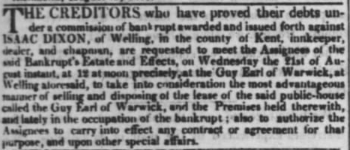
In 1816 he and most of the family moved from one side of London to the other - a huge move from Bexley in Kent to Harrow-on-the-Hill in Middlesex. The mystery is what attracted him to live in Harrow?. He would have found it to be a safe and quiet haven of tranquility. We also know from the Times of 10 December 1818 that he is described as a farmer. The Times 1818 also tells us that he had a partnership with Robert Dixon up to this time. The family moved into the newly built house in off West Street. This became known as the Victoria Dairy. When Isaac lived here there weren't as may houses and I’m sure thus was a detached house. Victoria Street was built about 1860. We know he kept a cart and at least 2 horses and had at least two cows that grazed down at the bottom of West Street before the enclosures took place. I imagine there would have been enough space around the house for the cart and the animals.
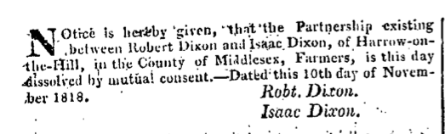
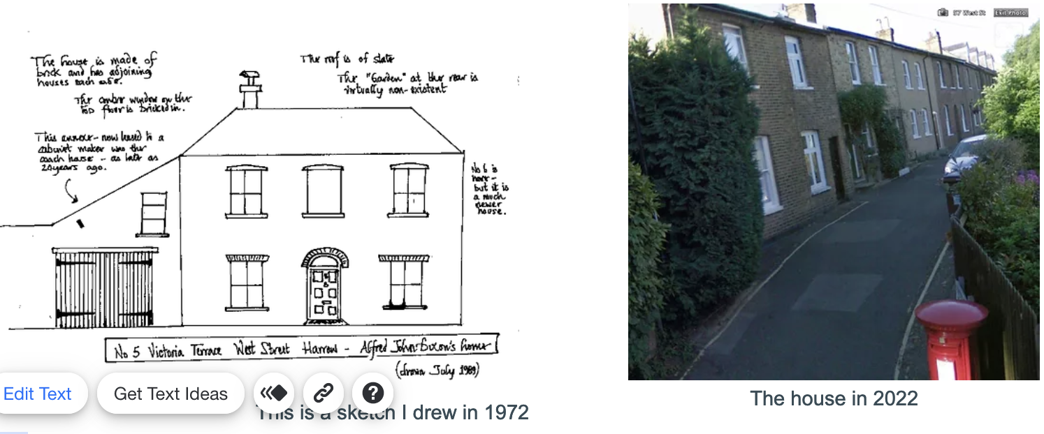I drew the sketch in 1981 and it was obvious that this had been the Victoria Dairy. You wouldn’t know it now though as the left side of the house has been replaced.
Isaac started the Victoria Dairy and he had his milk cart were a regular feature on the roads around Harrow-on-the-Hill, as he delivered milk to the residents and to Harrow School. I discovered this sketch (below left) in 2022, and the photo shows what the same scene looks like today. The two blokes leading the cart would be Isaac and his son Alfred.
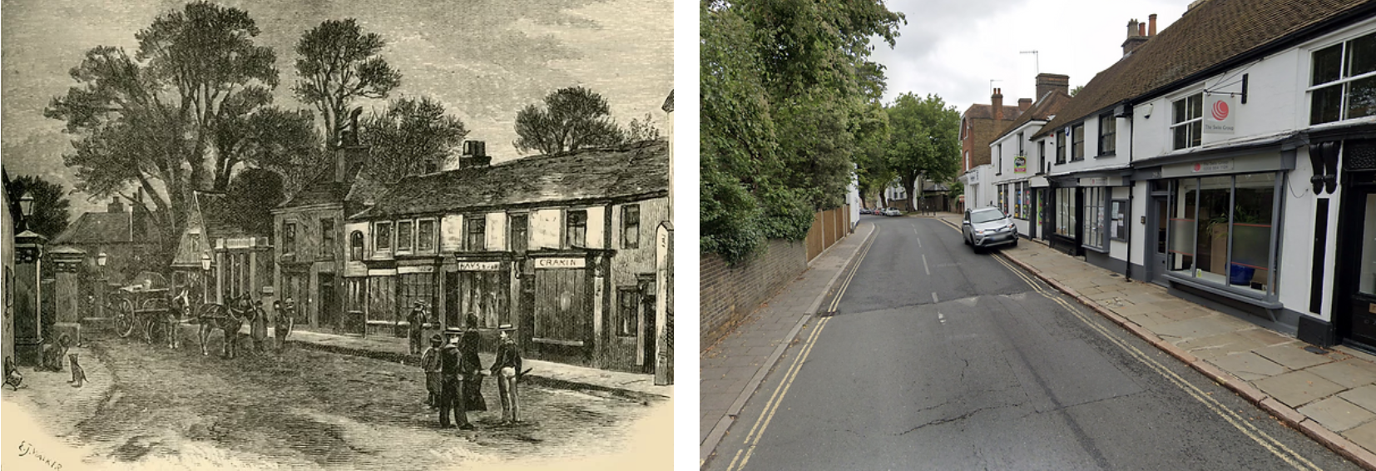

1843 - annus horribilis for the Dixon family
London was a cesspit of filth and disease in the 1850s. It’s hard to believe how different life was for our ancestors.
Dirt and smell were facts of urban life that equally contributed to the poor health of Londoners. People could not cross a road without the benefit of a crossing sweeper who cleared dust and horse manure from their path. The ‘summer diarrhoea' that occurred annually and killed many, particularly infants was largely caused by swarms of flies feeding on manure, rotting food and human waste left exposed in the hot, steaming streets. Smell was a potent characteristic of London life. In the 1850s London experienced the Great Stink, when the River Thames became a giant sewer overflowing not only with human waste but also dead animals, rotting food and toxic raw materials from the riverside factories.
The people believed that diseases, particularly cholera, were caused by contagion spread on the air, with the foul smells directly causing illness. This gave the Great Stink added terrors, as Victorian Londoners believed simply smelling the noxious odour of the Thames could kill them. In reality cholera is a waterborne disease. It was carried in the sewage polluting the city’s watercourses and passed to the capital’s population when they ingested polluted water.
The summer of 1858 was one of the hottest in memory, and the heat and lack of rain left the city stinking and the Thames a river of effluent. The Houses of Parliament had to be closed, as the river running beneath its windows became too noxious. Even soaking the window-blinds in strong-smelling carbolic of lime failed to keep out the Great Stink.
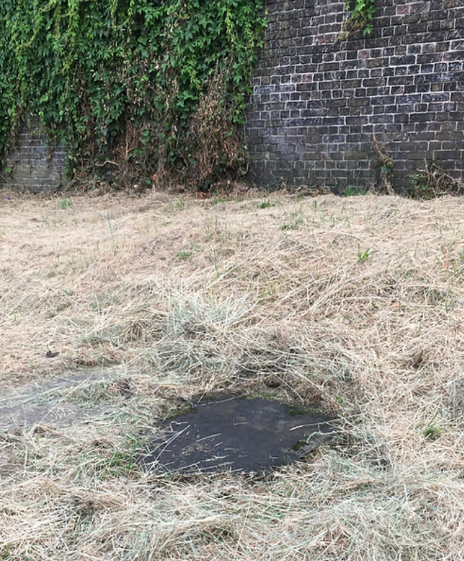
On New Year’s Day 1843 the family looked forward to another year but none of them knew the awful tragedy that was about to befall on them.
Clarissa, their eldest daughter came down with a serious sickness. Ann went down to look after Clarissa, but she died and was buried 15 May in St Mary's churchyard, and then the very next day, Ann died - 16 May. Isaac was unable to overcome his grief at losing three family members in less than a week, and he soon died and was buried 16 Jun 1843. Isaac and Ann are buried in a pauper’s grave at Kensal Green cemetery. In the same grave are Adeline Turner, their grand-daughter and 6 other bodies. Clarissa was buried in the churchyard because she was Church of England, but Isaac and Ann were Baptists. Shortly after Isaac died , another daughter, Clara also died.
The picture was taken in 2019. The charred black spot is in fact a gravestone marking the paupers grave. My thanks for the help received from Henry Vivean-Neal, a supporter of Kensal Green cemetery “I've checked 4173 in the records (Deceased Online only gives an incomplete picture - it's a long story). Un = unconsecrated and his remains are deposited in a common grave in the Dissenters (or unconsecrated) section of the cemetery. It's in square 7 of the cemetery and I went to the plot today - as it's a common grave (i.e., used for the burial of different (unrelated) people in the same plot) there's no memorial.” When we visited in 2009, Henry kindly led us to the plot.
This story was reproduced in the Belfast Chronicle, Bolton Reporter, Liverpool Standard and the Hereford Times.
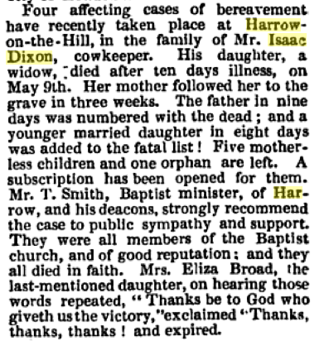 | 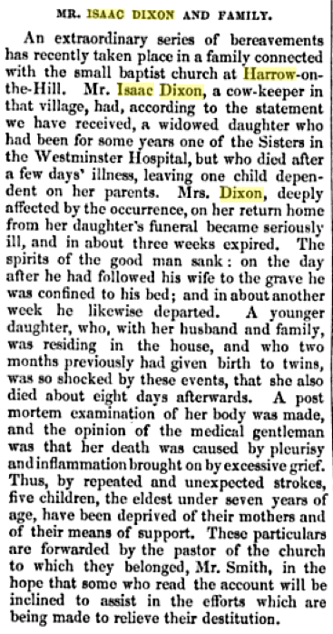
Above: The Baptist reporter 1843
Right: Baptist Magazine 1843

Isaac and Anne had seven daughters and then a son:
- Adeline Elvey Dixon baptised New Romney 15 Mar 1805 buried 18 Dec 1806
- Matilda Evans Dixon baptised New Romney 9 Mar 1806 buried 18 Dec 1806
- Jane Dixon b 27 Dec 1807 married John Barnes 1809 -1852. See Chapter 2 Gen 2: The Barnes
- Clarissa Dixon b 14 May 1809. married Nathaniel Punter. Nathaniel was born in 1810 to a well-off family. Nathaniel’s father was John Punter, Gentleman. John’s will dated gives details of the property he owned in Little Exeter Street, Salisbury Place, Lisson Grove, Westminster and a few more. The Punters were loaded. Clarissa and Nathaniel were married 27 Jul 1835 at St Marylebone. The family were living in Exeter Street, Marylebone (now Ashbridge Street) then at 12 Medway Street. Nathaniel worked at Westminster Abbey as a tomb carver and organ blower! He died five years into the marriage and was buried 20 Aug 1840. Shortly after, both of their children died and were buried on the same day. Clarissa then got a job working as a nurse at Westminster Hospital. Her husband’s mother was a patient at Westminster in 1843 and she died at this time. Clarissa caught some awful illness and took sick and her mum Anne went down to look after her. The Manchester Chronicle of 22 July 1843 states that “A daughter of Mr Dixon’s became a widow (having an infant daughter) three years since, and she shortly afterwards was placed as a sister in Westminster Hospital. Desirous of bettering her condition, she applied to the physician of that establishment, Doctor Rue, to assist her in that object, and that gentleman kindly recommended her as a nurse to a noble family about proceed to Ireland. On quitting the hospital in May, she visited her Harrow to take leave of her parents and child (whom she left at Harrow) and returned town preparatory to her joining the family alluded to; but on the day she was to have preceded to Clifton for that purpose, she was suddenly attacked with illness, and her immediate removal to be above hospital was recommended, but her case, baffling the skill of the medical gentlemen, death put an end to her sufferings in 10 days.” Clarissa died and was buried 15 May 1843. Clarissa and Nathaniel had two children:
  - Jane Punter b 1839 buried 27 May 1841
  - Emma Punter b 1836 buried 27 May 1841.
- Matilda Dixon b 21 Oct 1810 died aged 4 and is buried at St Nicholas Rochester.
- Adeline Dixon b 1811 baptised 17 November 1811 at St Nicholas church Rochester. She married George Turner on the 22 November 1836 at St John the Evangelist, Lambeth. Witness at Adeline’s marriage was Isaac Dixon ( her father). Another witness was Mary Eliza Elvee (her aunt). George was a furnishing ironmonger and the family lived in various places - 12 Kingsgate Street, 38 Kingsgate Street in Holborn and by 1881 are in Islington. Adeline Turner died 1890 in Islington aged 79. George died in 1898 in Hendon.
I know of the following children:
- William Turner b 1838
- George Turner 1841-1915; ironmonger
- Adeline Turner b 1847
- Alfred Turner b 1849 - went to school in Rochester and by 1871 is a solicitor's clerk
- Mary Anne Turner b 1851. Still living at home in 1881 unmarried aged 28.
- Clarissa Dixon b 1853. Still living at home in 1881 unmarried aged 28.
- Eliza Dixon bap 5 Sep 1813 at Bexley, Kent. She married William Broad, a shoemaker on 1 Dec 1838 at Trinity church St Marylebone. John was born in Barnes, the son of John Broad, a carpenter. In 1843 she lost her sister Clarissa, her mother and father and she also died in 1843. The Baptist reporter quotes her on her death bed as saying "Thanks be to God who give us the victory. Thanks, thanks, thanks." I wouldn't say that on my death bed - but the times were completely different then. Eliza and William had three kids:
  - Emma Broad b 1840
  - Edgar Broad b 1843 d 1848
  - Clara Broad b 1843 d 1852
- Alfred John Dixon b 9 Jul 1815 d 27 Jan 1878 – see Chapter X Gen 2.

Chapter Two Gen 2: Jane Barnes nee Dixon
Isaac Dixon > Jane Dixon = John Barnes
Jane Dixon, daughter of our first ancestor Old Isaac of Welling was born in Bexley, Kent 27 Dec 1807 and moved with the rest of the family to Harrow on the Hill.
She met and married a tailor called John Barnes who was born in Codford St Peters, in the middle of Salisbury Plain, Wilts in 1809.I expect that they met when John came up to London on a shopping trip or perhaps John was training as a tailor?
John and Jane were married in St Peter Walworth on 6 June 1831 by Gilbert Chesnutt, Assistant Minister in the presence of Miss Williams. Clarissa Dixon and Adeline Dixon (her sisters) were witnesses.
After their marriage they lived in Walworth because the first child, Adeline was born there in 1832. They were strong in their religion like their parents. Her parents were Baptist and we see this family are Wesleyans / Methodists.
The young family moved to a very remote village in the middle of the Salisbury Plain in 1833. Why Tisbury? Tisbury was a hotbed of dissenters. Between 1818 and 1848 nine dissenters' meeting houses in Tisbury parish were certified. In 1846 a small, hexagonal, stone chapel was built for Wesleyan Methodists at the Quarry in Tisbury village. And it was hive of activity for tailors, so they moved here for work.
In 1825 a short-lived industrial venture began with the building of a cloth factory at the southern end of Fonthill Lake. There was a 6-storey block, a 5-storey factory with 3 water wheels, a drying house and a dyehouse. The buildings were erected by the eccentric Mr Farquhar, a retired gunpowder maker, and completed by 1827 with a house and 24 cottages. The idea was to weave a superfine woollen cloth and 200 people, mainly from Gloucestershire, were employed. Despite an abundant supply of water, the venture failed, probably as this was a remote area, with poor communications and a factory could not compete with the steam powered ones of western Wiltshire that were sited near canals. The machinery was sold in 1830 and the buildings demolished between 1838 and 1886.
In Tisford they lived at 9 Tuckingmill and John was a tailor and Jane was a “taylor’s wife”. Their neighbours were a cheese merchant and on the other side a pauper. Three doors down lived the family of John Goodellow, a carpenter aged 25 unmarried.
The photo below shows the chapel where the family worshipped. It’s an art studio now. And the photo on the right is the street heading up to Tuckingmill.
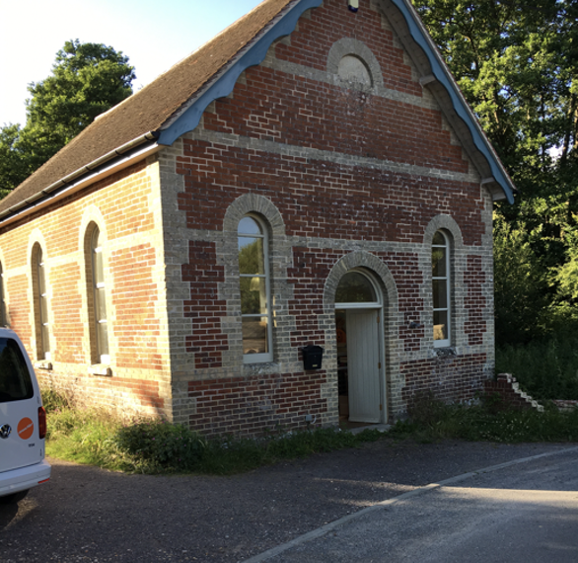 | 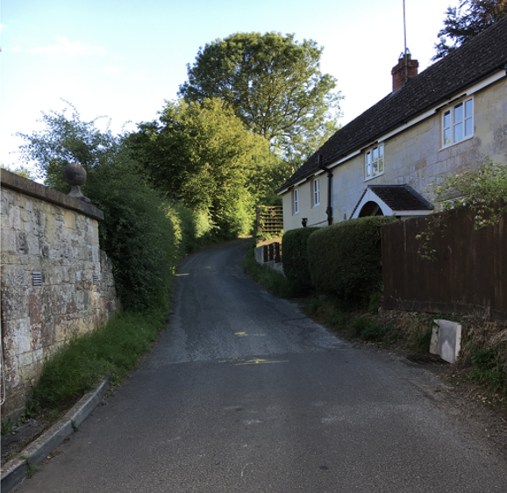

Jane and John Barnes children:
- Adeline Barnes 1832- 1917 = James Hunt 1838 -1921 Chapter 3 Gen 3.1
- Clarissa Barnes 1834 – 1925 = John H Goodfellow see Chapter 4 Gen 3.2
- Adolphus Barnes 1836 – 1909 = Elizabeth see Chapter 5 Gen 3.3
- Walter Barnes 1838 - 1853
- Annette Barnes 1844 - 1852
- Fanny Jane Barnes 1846 – 1930 = Henry Bellman see Chapter 6 Gen 3.4
- Ellen Barnes 1850 –

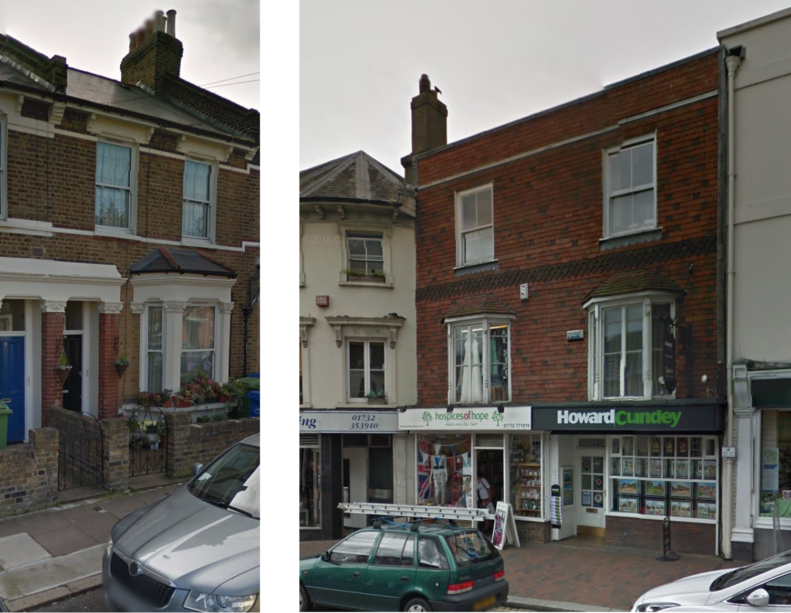
11 Landcroft Road Camberwell 136 & 138 High Street, Tunbridge, Kent

Chapter 3 Gen 3.1: Adeline Hunt nee Barnes
Isaac Dixon > Jane Dixon = John Barnes > Adeline Barnes = James Hunt
Adeline Barnes b 16 Jan 1832; baptised 28 Oct 1832 Wesleyan chapel Walworth. Adeline had left home by 1851 and in 1857 was living at 7 Mount Street Newington back in London. She married James Hunt son of William Hunt a farmer from Borstall, Bucks. James was a draper and she married 25 Dec 1857. They too, are not to be found in 1861, but from later censuses we find that James does quite well for himself. In 1871 and 1881 they are living in a house in the High Street in Tunbridge, Kent; in 1891 they are in 2 houses – 136 & 138 High Street and James is a draper and outfitter; 1901 they are at 146 High Street and by 1911 they again have two buildings – 144/146 High Street. The photo below is of the same location but taken in 2022.
The 1911 census is useful in that it tells us that James and Adeline have been married 56 years and that they had three children, 2 of whom were still alive.
Adeline died in the March quarter of 1917 aged 84 in Tonbridge. James died 23 Apr 1921.
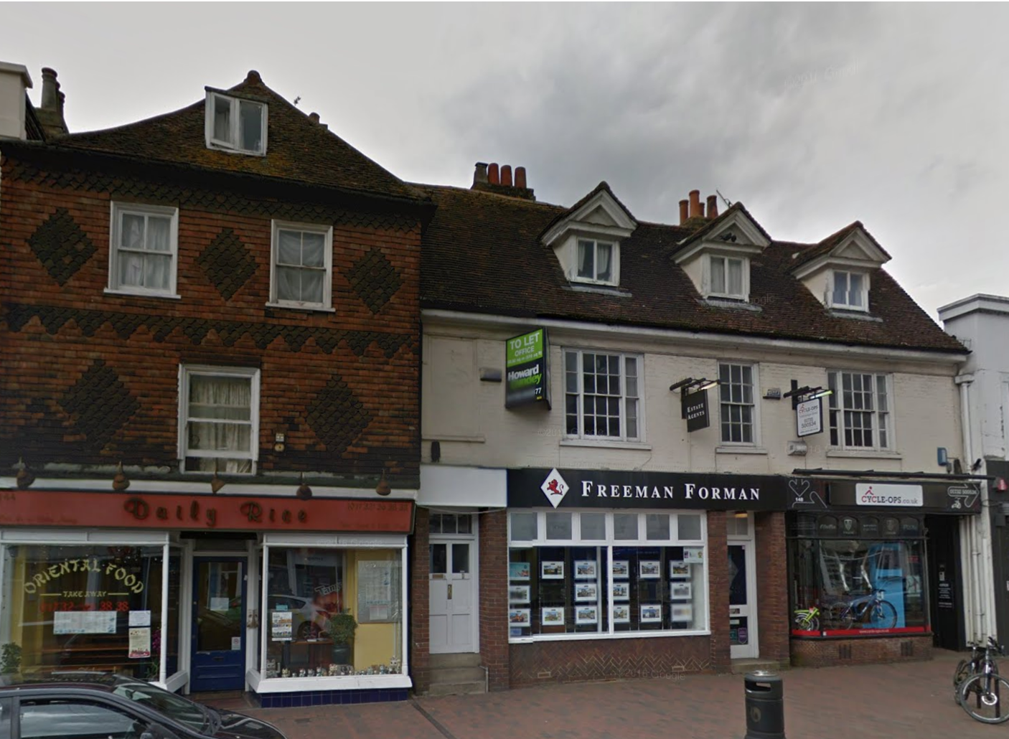

We think of drapers as the people we see in the BBC TV series the Paradise and ITV’s Mr Selfridge – astute businessmen making a good living selling clothes. Nothing could be further from the truth. In the nineteenth century, drapers were despised. HG Wells (author of the Time Machine and War of the Worlds) did a draper’s apprenticeship and write about the drudgery and feeling of entrapment. The feeling of the day was that male drapers were thought to prey in an unchivalrous way upon ‘weak’ women, tempting them to get into debt to buy the latest fashions. They were unpopular with men because much of the household cash went to the drapers to outfit their women.
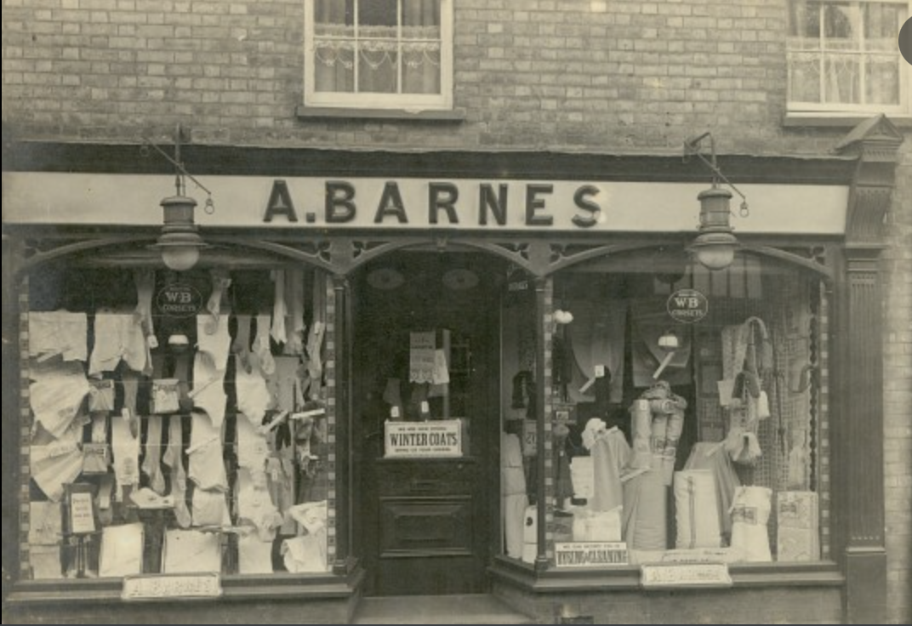
Photo above is not our Barnes drapers, but was situated in Chatteris, Cambs. Our ancestor’s shop probably looked the same
However, drapers faced the same difficulties that all shopkeepers encountered but they also needed to keep pace with an ever-growing range of textiles, including newly developed artificial fibres, that had to be aware of the latest fashions, and were expected to talk authoritatively about the qualities and care of fabrics to an often fussy female clientele.
The retail linen draper draped selected fabrics across his doorway so they could be seen and felt. Since ready-to-wear clothes were not readily available until the mid-19th century drapers were in great demand by seamstresses and tailors. The London establishments were sometimes huge, with dozens of live-in staff called draper’s assistants, as can be seen from the census returns. We can see that the Barnes had lots of staff even in their small shops.
James and Adeline had three children:
- Ada Louisa Hunt born in Nunhead, Lambeth in 1861. Ada never married, stayed home and worked in the drapery business. When James died his estate went to Ada, effects £2292.14s.6d. She was a draper’s assistant and a spinster. She died at 46 Tadlow Road, Tonbridge aged 73 on 17 Jan 1935. Effects £1184.0.3d to Clara Line Smith.
- Clara Lina Hunt born Nunhead Surrey David was in the drapery business like her dad and they lived all over London – Islington, Stamford Hill, In 1901 she and David were living at 46 Milner Square, Islington; n 1911 he was a linen draper’s salesman. In 1891 they were living above their own drapers shop at 6 Stamford Hill (just up from the Weavers Arms).In 1911 they were at 10 Ennis Place, Finsbury Park. Clara died in 1939 aged 79 in Edmonton. She is missing from the census for 1861 and 1881. Clara and Charles only had two children:
  - Cecil Charles Smith b 31 Jan 1886 Bermondsey. He became an electrical engineer. In 1911 he lived in Dulwich 128 Craxted Road and was lodging with Edward Buckingham, a meat salesman. He married Ivy Florence Vogel (b 31 Dec 1885) in July 1918 in St Pancras. In 1939 he was living in Battersea and working as cost accountant at a motor transport company and died 19 Oct 1955 at St Benedict’s Hospital, London. £1529. (The photos are from peternicholls150 on ancestry.com).
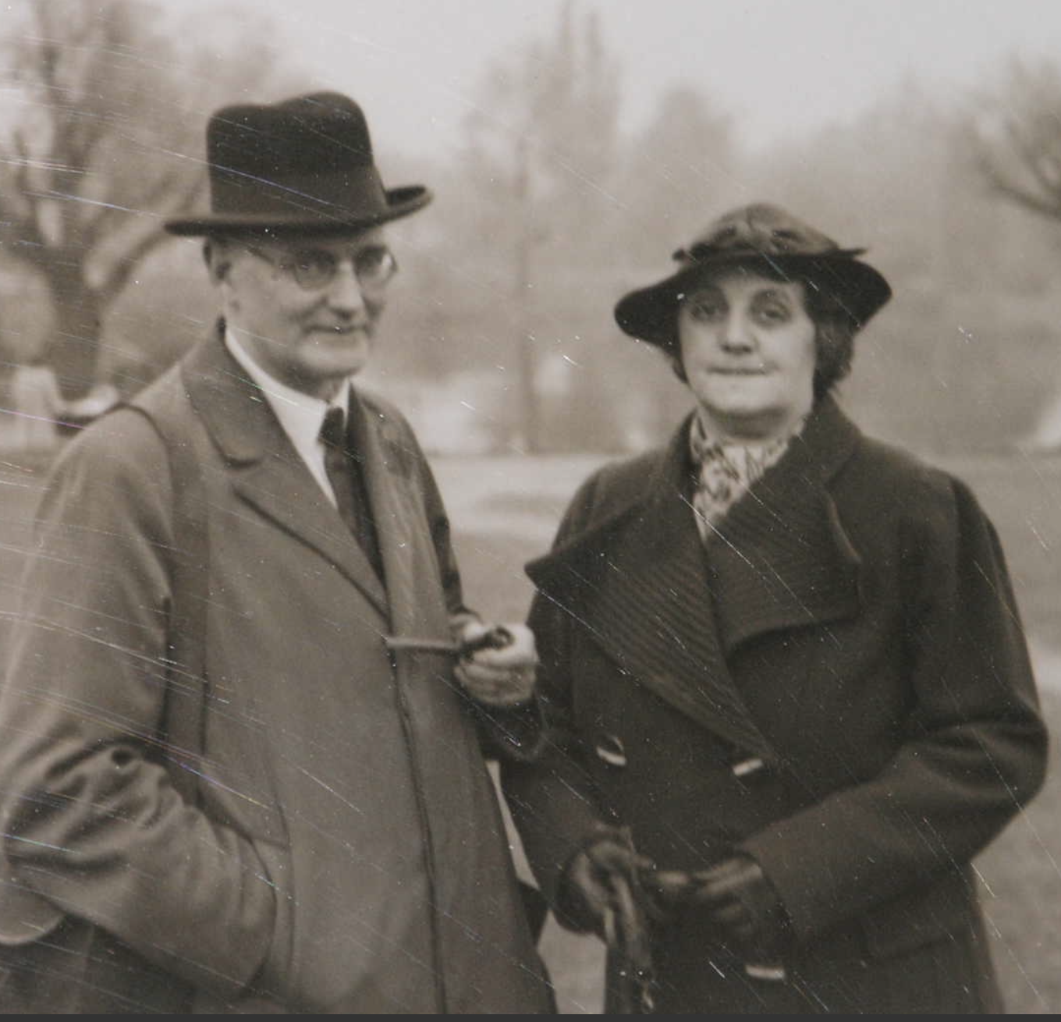 | 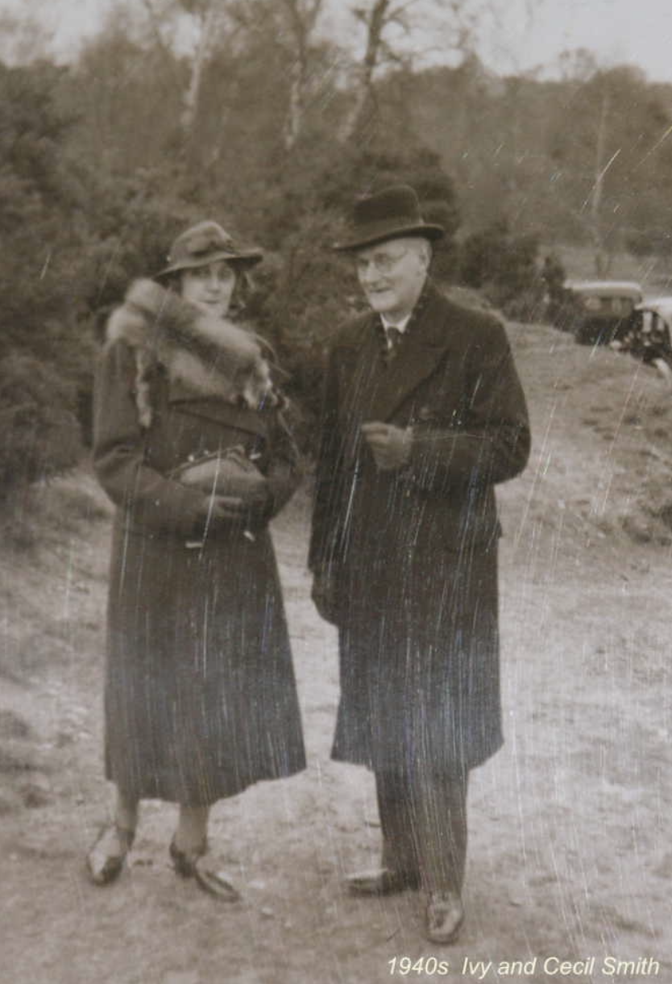
Cecil and Ivy had a son:
    - Dennis Cecil Smith b 31 Aug 1920 118 St George’s Avenue, Tuffnel, Islington. d 31 Oct 1996 Hammersmith. Dennis lived in Radlett, Hertfordshire for 30 years. During WW2 he was a lieutenant. Dennis married Joan Beatrice Morton, who was in the ATS Whitehall Signals and afterwards worked as a primary school teacher. Joan was born 3 Sep 1920 at 8 Wanderers Avenue, Wolverhampton. She died 5 Oct 2018 at Perrins House, Moorlands Road.

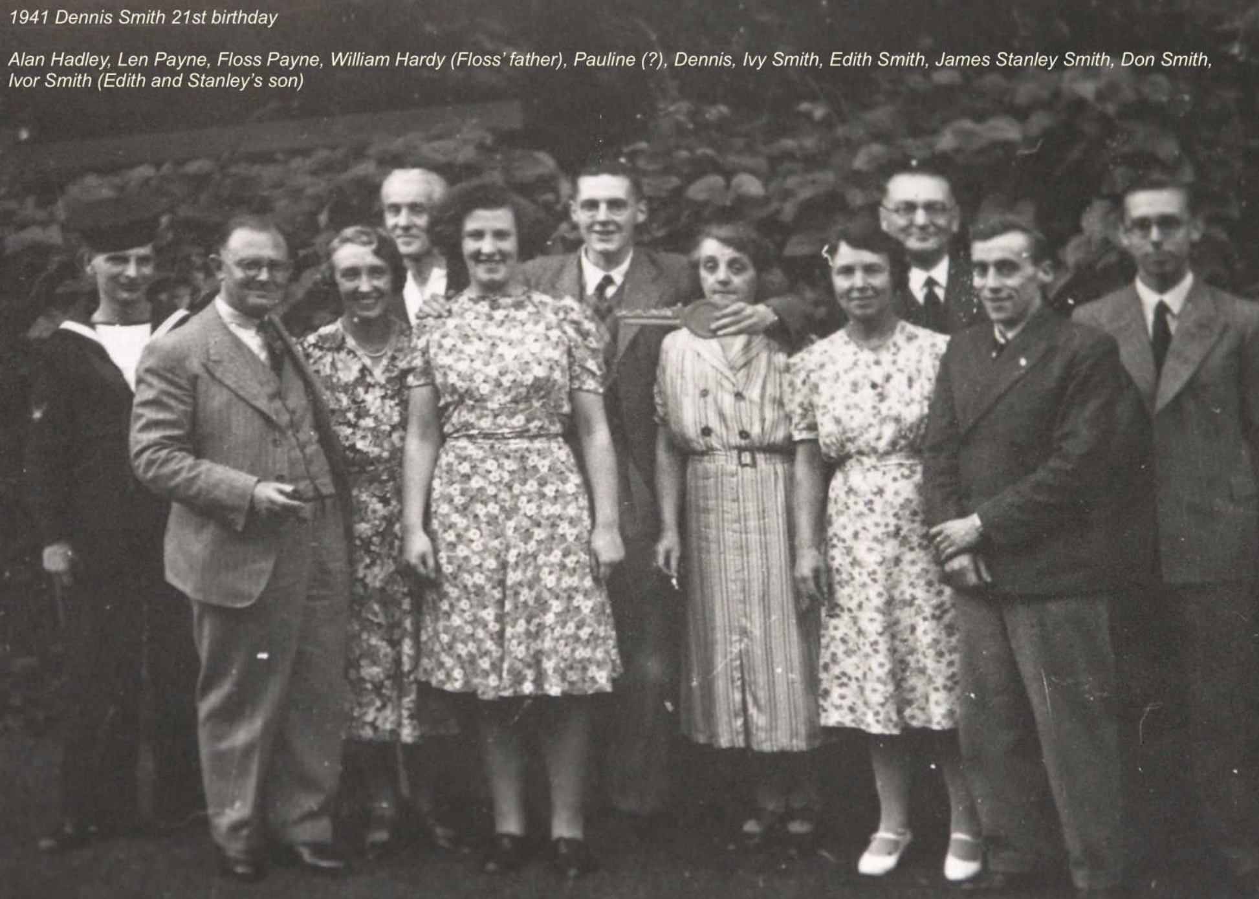 | 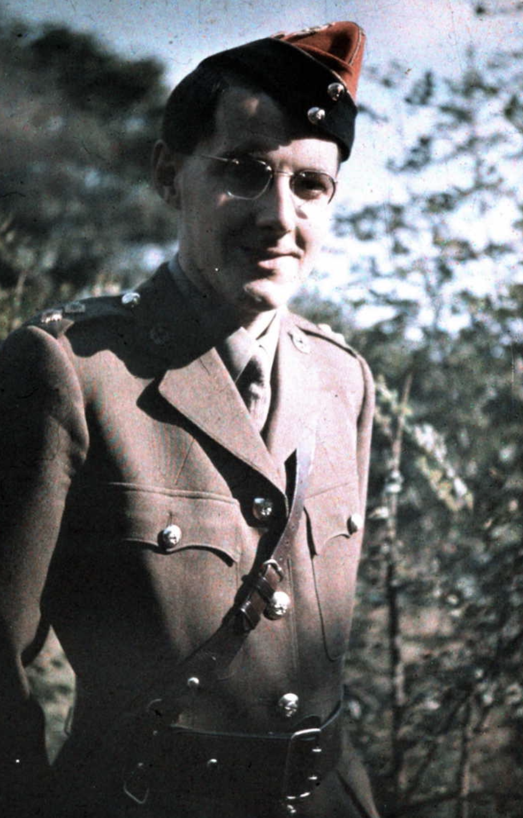

  - James Stanley Smith b 3 May 1888 Stoke Newington. He became an electrician and by 1939 was a travelling salesman for an electrical engineering company. During WW2 he was an air-raid warden for Ealing. James married 5 May 1918 to Edith Kathleen Doe at St Augustine, Paddington. Edith b 18 Apr 1894 and died at 69 Whitton Avenue East, Greenford 23 Mar 1974. Probate £1211. They had a son:
- Ivor S Smith b 14 Apr 1922. He became a capstan lathe setter operator. He lived at 97 Hornsey lane, with his wife Audrey D J.

Chapter 4 Gen 3.2: Clarissa Goodfellow (nee Barnes)
Isaac Dixon > Jane Dixon = John Barnes > Clarissa Barnes & John Hannam Goodfellow
Clarissa Barnes was the second child of Jane Dixon and John Barnes b 11 Mar 1844 and christened 30 Nov 1834 at the Independent chapel in Tisbury. A few doors down there lived a lad called John Hannam Goodfellow and they may have been childhood sweethearts because Clarissa and John were married. There are many instances of Goodfellows to be found in the jewellery and clock making industries. John Goodfellow was born circa 1807 in Ditcheat, Somerset and trained to become a carpenter. I expect he was there because of the new works that were being put up, but after the enterprise folded, the couple moved onto Frome in Somerset. She became a milliner. In 1861 they were living in Frome, Somerset at 8 Lower Keyford. John did well for himself and learned many new skills and they moved to High Wycombe, where, in 1871 John was the foreman of an iron works in High Wycombe. They lived in Castle Street. The enumerator didn’t put in the numbers.
Meantime a couple of their children had moved to Leicestershire where they were apprenticed to become jewellers and watchmakers.
John died 25 Feb 1883 at Baltic Road, Tunbridge – he was worth £150. Clarissa then moved to Leicestershire to live with her sons learned the watchmaking and jewellery trade. In the 1881 census Clarissa is listed as a visitor and staying with Robert James aged 63, a farmer of 48 acres at Batscombe, Somerset. Her son aged 19 was with her. His occupation that of a draper’s assistant. By 1891, the whole family was staying at Edgar’s house – way up in Leicestershire. Edgar and Sydney are listed as watchmakers and jewellers and they are living at 30 ½ Castle Street in Hinkley, Leicestershire. (That’s right 30 and a half!!). Edgar is the head of the household, and there is Laurie C who is listed as a wife – not sure if that is the wife of Edgar or Sidney. Edith is also at home – a close knit family. In 1901 Clarissa was a matron of a nursing home in Leicester and living at 45 Princess Street aged 65 with one servant.
And in 1911 she was living in the home of her daughter’s husband at Brook House, Syston, Leicestershire. This is a confusing entry as the head of the house is George John Bruford (watchmaker, jeweller and shopkeeper) who had been married 21 years and had two children, one still living. In the house was Edith Lavinia Goodfellow (wife’s sister) aged 47 single b Frome, 5 boarders and Clarissa Goodfellow aged 77 a widow. Under birthplace, Tisbury Wilts was originally put in but that a line through it and the words Walworth London.
Clarissa led a good and healthy life and died in the June quarter 1925 at Barrow upon Soar, Leicestershire
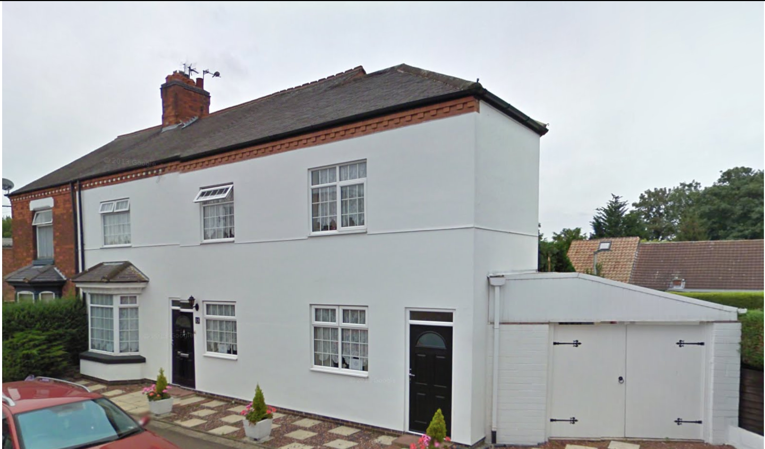
Brook House, Syston, Leicestershire
Children of Clarissa Barnes and John Goodfellow:
  - Sidney John Goodfellow bap 26 Dec 1858 Ditcheat, Somerset. He trained as a watch and clock maker and was in Shepton Mallet in 1881 visiting friends (possibly his employer) at the Railway Inn. He married 6 Feb 1888 at Hammersmith to Laurie Carlisle Cupper. In 1891 and he was living and working for his brother at 30½ Castle Street, Hinckley, Leicestershire. He lived at 26 St George’s Road and worked as a watchmaker. In 1896 Sidney died at the Isle of Weight aged just 37.
  - Edgar Goodfellow bc 1858 and baptized 26 Dec 1858 in Frome, Somerset (pronounced Froom). Sidney was the second child of Clarissa and John Goodfellow. He started work as a draper’s assistant – we find him on holiday in Baltonsbrough Somerset in 1881. But he changed his job and became a watchmaker and in the 1891 census he was the head of the house at 30½ Castle Street, Hinckley, Leicestershire. Also in the house was mum Clarissa (widow), brother Sidney, also a watchmaker, Laurie C, his wife and sister Edith. In 1901 he is in Torquay and describes himself as living on own means. His wife is with him – Mary Griffin Wood b Leicester. He might have been there on holiday. Castle Street is now a pedestrian thoroughfare, and I can’t get pictures of the street. In 1901 he has a different wife – Mary G aged 35. They are living at 2 Lucius Street Torquay where Edgar has a jewellers shop. It would have been in the shop in the foreground. Edgar and Mary would have lived above the shop. The records show that he died in 1918 in Wortley in the West Riding of Yorkshire.
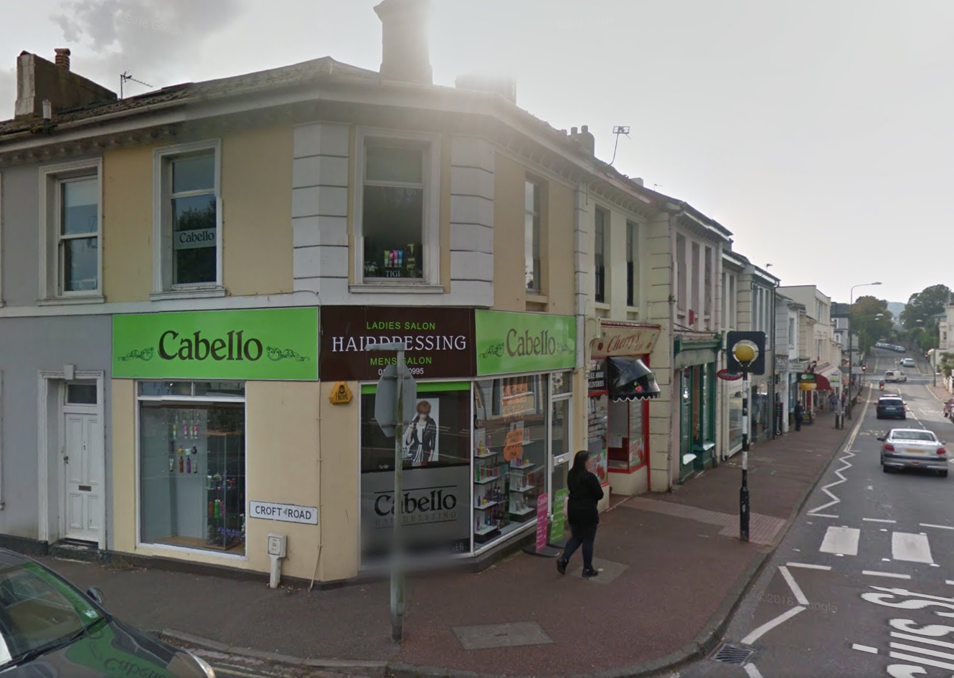
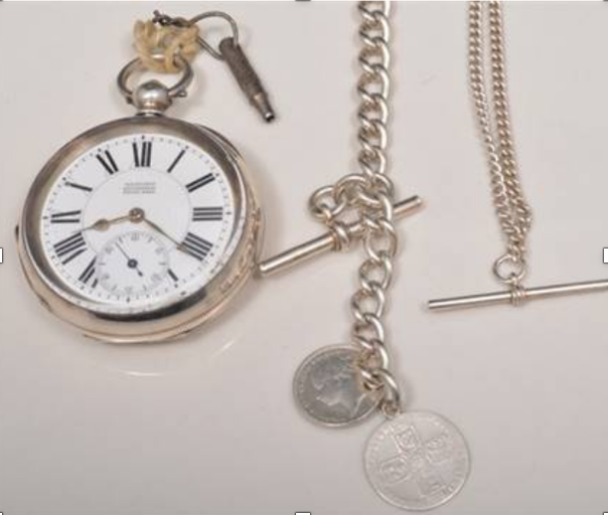
Silver pocket watch, 1935 standard, white enamel dial signed Bruford, Leicester, Swiss movement, diameter 55mm, a silver albert with two silver coins serving as fobs and another watch chain. Sold for between £30-50 in 2015

There is Bruford jewellery store established 1886 in Eastbourne , they don’t know it but they are related to the Leicestershire branch.

  - Edith Lavinia Goodfellow bc 1864 Frome was the third child of Clarissa and John Goodfellow. In 1881 she was living with her aunt in Tunbridge (Adeline who married James Hunt) and working as a drapers assistant. From 1891 she was living with the family in Hinckley. And she was in the Bruford household in 1901 at Brook House, Syston – see picture of Brook House above. She never married. She died 1930.
  - Clarissa A Goodfellow b 10 Mar 1865 Frome. At the age of 15 (in 1881) she was at boarding school at 134 Albany Street Marylebone (Ladies College run by Elizabeth Johnson). She helped turn the family fortunes around when she met George John Bruford. George was born in Westminster and followed his father into the jewellery trade. His father became a jeweller in Hampstead, London in the middle of the nineteenth century. But for some reason they moved up to Leicestershire and in 1891 they are together in Leicester at 3 Victoria Parade near the Corn Exchange, right in the middle of the town. Funnily enough there are now two pawnbokers in the same area. Victoria Parade is the lane in the foreground.
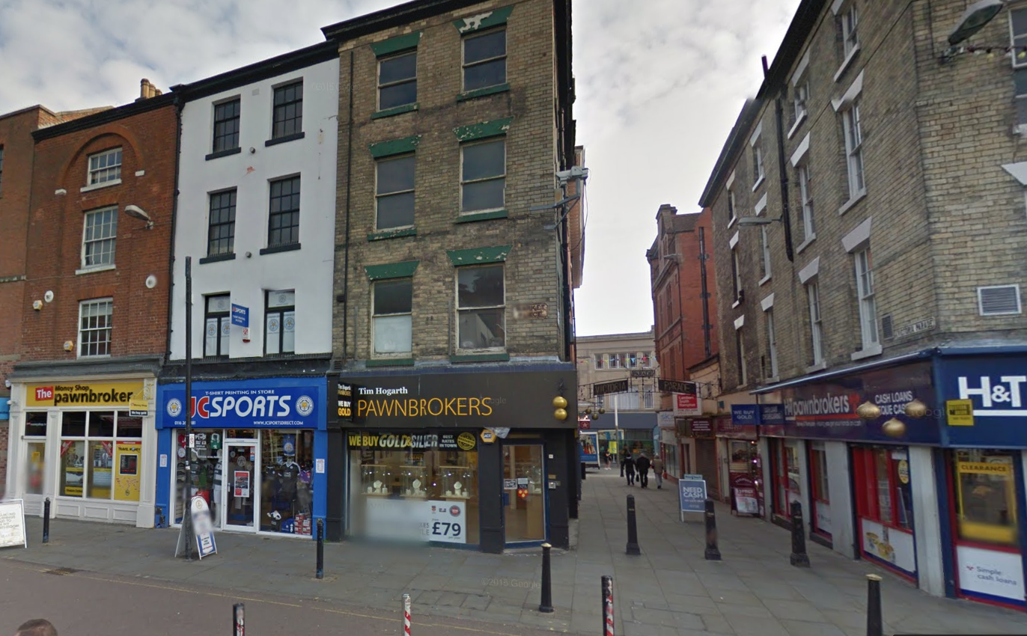\
They must have done OK because ten years after this in 1901 they have a house at Birstall Hill, Leicester. They had moved out from the old town centre. Sadly Birstall Hill is no more – all new development.
The business in Leicester took off - the shop was located right in the centre of town and would have been a popular place to shop. George created Bruford & Co (no relation to Bruford & Son).
By 1911 the family were ensconced in the big house at Sysford together with 6 boarders who would have helped the family coffers. However Clarissa wasn’t at home on the night of the census. She was staying at Everfield Hotel in Hastings taking a well-earned holiday.
NOTE: George had an uncle - his dad’s brother William b 1838 who established the Bruford jewellery emporium in Eastbourne – still going from strength to strength. Children of George and Clarissa Bruford:
    - Reginald Bruford b 1892 and d 1909 Leicester
    - Cyril Norman Bruford b 25 Jan 1896 Hinckley we find him aged 15 in 1911 as a visitor at Hastings, described as a schoolboy. He may have been on holiday with his mother, or boarding and mother was visiting. and working as a jeweller’s assistant. When WW1 broke out he was 19 he was conscripted into the Army 11 Dec 1915. Army records are an excellent source of information. Cyril was 5’11” and had a girth of 36.5 inches fully expanded and an expansion range of 4 inches. He had blue eyes and dark brown hair Rifleman Bruford joined the London Regiment 12th Territorial Force. His regimental number was 4966. He was discharged 30 Aug 1916. He did not serve overseas and the reason for discharge was “no longer physically fit for War Service, “Para 392 XVI K.R.Sick 18912” The report of the Medical Board dated 16 Aug 1916 states “Origin 1903 Leicester. Had rheumatic fever 1903 and again 1909. Has always had shortness of breath and palpitations of heart since. Could not play ordinary boys’ games at school in consequence of disability. Not the result of Military Service – not stated if aggravated by Permanent. Can earn his livelihood at his employment service.” Poor young man has REJECTED stamped across his record!
“Rheumatic fever (RF), also known as acute rheumatic fever (ARF), is an inflammatory disease that can involve the heart, joints, skin, and brain. The disease typically develops two to four weeks after a streptococcal throat infection. Signs and symptoms include fever, multiple painful joints, involuntary muscle movements, and occasionally a characteristic non-itchy rash known as erythema marginatum. The heart is involved in about half of cases. Damage to the heart valves, known as rheumatic heart disease (RHD), usually occurs after repeated attacks but can sometimes occur after one. The damaged valves may result in heart failure, atrial fibrillation, and infection of the valves.
Poor lad – but he lived to the age of 59. In 1919 he applied and was granted Freedom of the City of London in the company of spectacle makers as a goldsmith and optician.
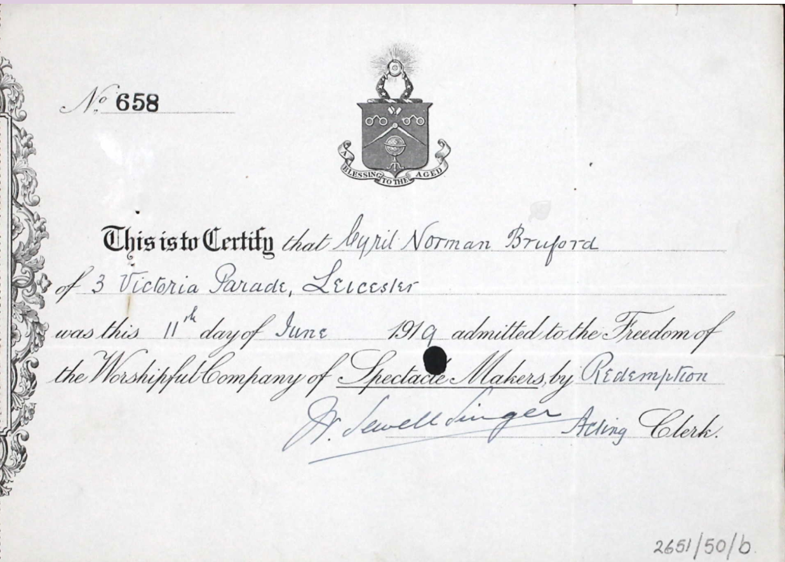
He is in the 1925 Kelly’s Directory of Rutland as a watchmaker at 11 Marlboro Street, Leicester. And in the 1939 Register he is living at 49 West Street, Leicester and his job is of a mechanical nature - something I can’t make out.
.
Cyril married Kathleen Margaret Jackson in 1924. He died in Brighton in 1955. They had two children:
    - Sheila K Bruford b 1926
    - Cyril Heigh Bruford b 1930. d Horsham 1952. His son was
        - Stephen David Nicholas Bruford b 195
No details of these are available although I think they lived in Brighton.

Chapter 5 Gen 3.3 Adolphus Barnes
Isaac Dixon > Jane Dixon= John Barnes > Adolphus = Elizabeth

Adolphus Barnes, the third surviving child of Jane Dixon and James Hunt was born in East Tisbury, Wiltshire on 12 Feb 1836. He was still at home in 1851 helping dad with tailoring. Like the rest of the family, he doesn’t appear in 1861. However at some stage he makes the move to London.
He married Elizabeth Jane Smith. Elizabeth was b 14 Jan 1840 in Winterbourne Stoke, Wiltshire. She was a Moonraker. (moonraker - means a person from Wiltshire). Her father was a coachman. When she met Adolphus, she was working in Marylebone as a housemaid to a solicitor. They were married at the church of St Peter, Eaton Square, Pimlico in the summer of 1861. Interesting that Adolphus’ father was a tailor but he stated that his dad was a farmer.
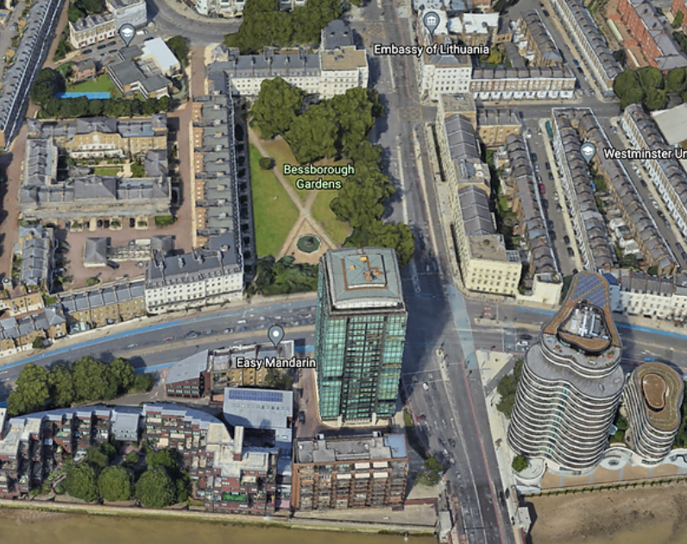
In 1871 he and Elizabeth are at 36 Lupus Street, Belgrave. The street is still there. Lupus Street runs to the north and west of the massive Churchill Gardens Estate. The estate was later developed between 1946 and 1962, replacing the Victorian terraced houses which Adolphus would have known so well. They had been extensively damaged during the Blitz. I can’t make out his occupation in 1851 but in 1861 he describes himself as a harness maker and now the family is sharing a house with another family in 21 Bessborough Street/Place. 21 people (4 families) lived in the house. This area was destroyed by German bombing and pulled down in 1953. Interesting that the old river Tyburn was also located just one street away, although by this time, it was buried in the developing London sewers - see Kings Scholar Pond Sewer.
Adolphus married again in the spring of 1878 to Winifred Powell. Winifred was born in 1846 in Southampton.
In 1891 he is listed as a harness maker lad (?). They are living at 39 Vauxhall Bridge Road with 3 other families (11 people). The kids have left home. In 1901 they had moved again to 13 Sussex Street, Forest Gate sharing the house with another family.
​
Adolphus’ final few years were fraught with disease and poverty. The records tell us that on Tuesday 22 Nov 1898 he was admitted to Fulham Road workhouse aged 63. In 1901 we find that he has left the area where he had spent the last 30 years and moved east to West Ham to 13 Essex Street.
He died in 1908. Winifred was admitted to Fulham Road workhouse on 4 Apr 1898. Her occupation is given as charring (a cleaner).
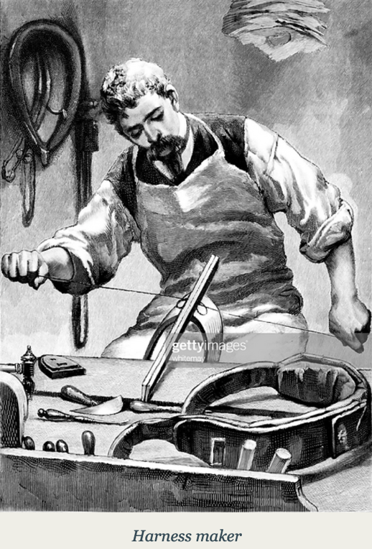
And the sad thing is, Adolphus's sisters were doing quite well and could have bailed him out.
​Children of Adolphus and Elizabeth
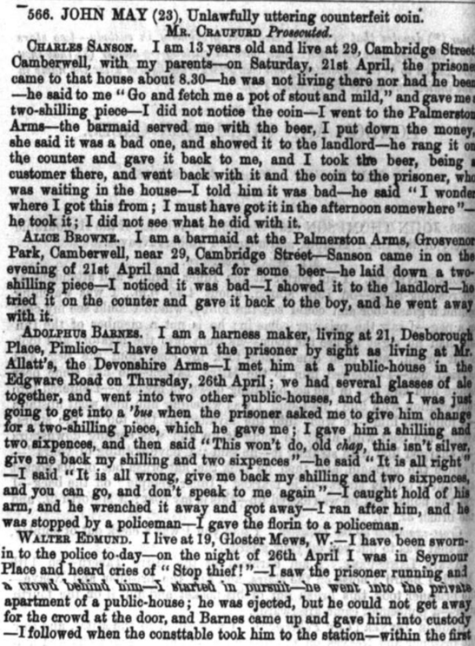
- Walter Barnes b 3 May 1863 Pimlico and married Mary also known as Marion Cullingford (b 8 Apr 1866 in Beccles). He didn’t follow in his father’s footsteps but was helped by his uncles and aunts and became a draper. He lived and worked in Rochford In the 1939 census he is living in Rochford Essex at Sydenham House. Three children:
  - Mabel Barnes b 1892 = Walter Mounsey
  - Harold Gladstone Barnes 1893-1969. Harold was a soldier in WW1 when he married Jessie McDonald on 9 June 1917 at St Michael’s church Wood Green.
  - Winifred AP Barnes 16 Nov 1901 solicitor’s clerk (1939)
- John Adolphus Barnes 1861-1899 aged 38. no records of marriage
- Primrose Barnes 1867
Children of Adolphus and Winifred Barnes:
- Florence Barnes b 1879 Pimlico d 1933 married Sydney Frazer Francis was a draper and was b 1871. He died 1919

Chapter 6 Gen 4: Fanny Jane Bellman (nee Barnes)
Isaac Dixon > Jane Dixon = John Barnes > Fanny Jane = Henry Bellman
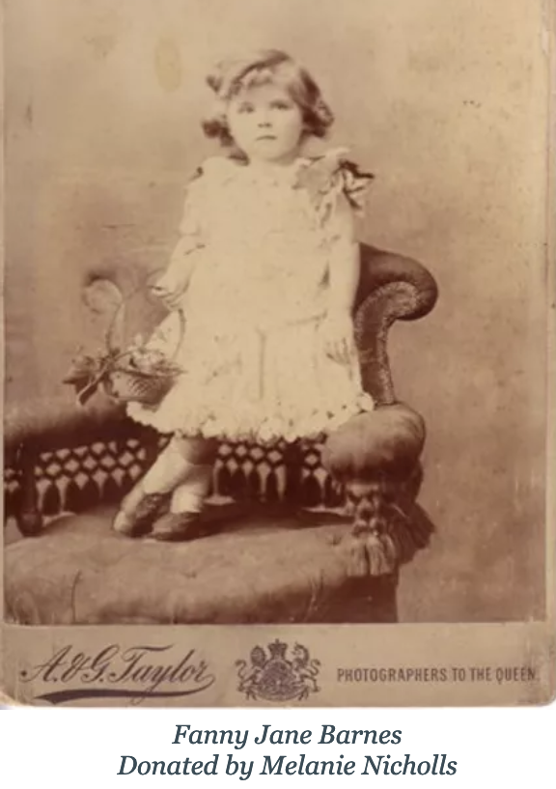
Fanny Jane Barnes was born in Tisbury, Wiltshire 16 Jan 1846. She married Henry Joseph Bellman at St George Hanover Square. Henry was born 27 May 1847 and baptised 20 June 1847 at St Peer's church, Pimlico. His parents were William and Joanna Bellman of Ebury Street. William was a publican. They were married 29 Jan 1865 at the same church and they lived at 11 Landcroft Road, Camberwell. Henry was a commercial traveller in silks.
By 1881 Henry was a warehouseman which was probably a step down. They were living at 10 Horchall (?) Road, Sydenham. 1891 but they have a servant. Ten years on and Henry has returned to being a commercial traveller. They were living at 47 Glengarry Road, Camberwell. By the time of the 1911 census, Henry is dead and Fanny was now living with her daughter Jessie – see below.
Fanny died 23 Station Road, Clacton-on-Sea 18 Jul 1930. I have often wondered if she knew that she had relatives (my grandfather) who were living there at the time. She surely must have done. She would have eaten in their restaurant.
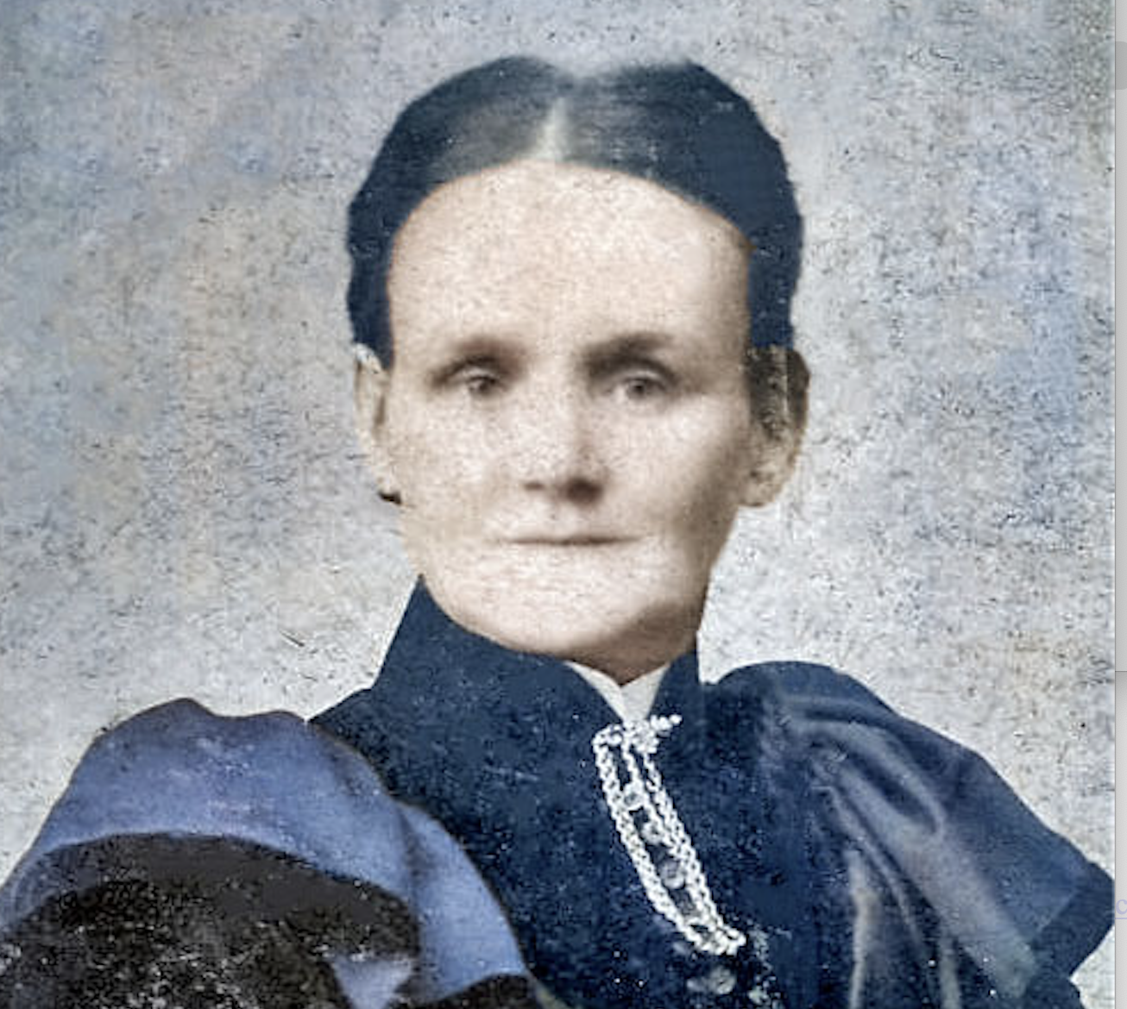  Fanny Barnes from Chris LamSam | 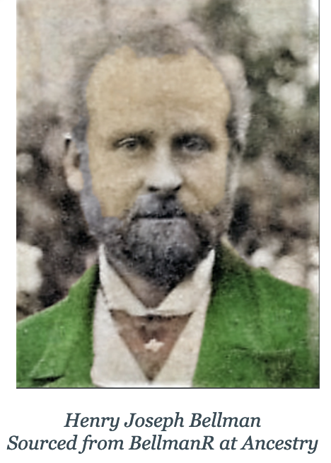
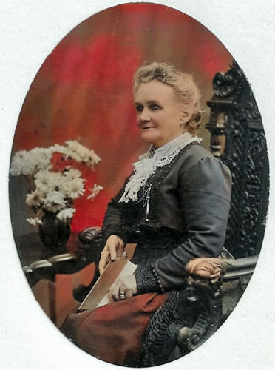
Henry and Fanny Bellman had 10 children. They were certainly ahead of their times in naming their children. Quite different from the majority of the population who did not have very imaginative names. These children embraced the idea of expanding the British Empire and were jet setters of their day:
- Henry Douglas Bellman 1869 – 1932 See below
- Jessie Helen Bellman 1869 – 1932 See below
- Harold James Bellman b 13 Feb 1870 died 14 Jun 1900. Brisbane Australia. He was a steward on board ship and he jumped ship when the it docked in 1891 perhaps to seek riches in the goldfields of Australia. He was missing for many years and in desperation, in 1908, his mother put am advert into the NSW Police Gazette for a missing person. We don’t think Harry ever got back in touch with his family as he died in Brisbane 14 Jun 1900
- Duncan Mathison Bellman 1872 – 1873
- Franklin Charles Bellman 1874 – 1955 See below
- Gordon Leslie Bellman 1876 – 1934. Married Edith Ann Crowson. Children
  - James Leslie Bellman 1906-1975 married Hilda Wildy. Issue:
    - Francis E S Bellman married Vernon Prior 1932. Issue:
      - Anthony G Prior b 1958
      - Susan Prior b 1960
  - Edith Irene Bellman married Harry Pegler. Issue:
    - Jean Pegler b 1972
    - Margaret Pegler b 1930
    - Michael Pegler 1942-1989 = Lilian Nion
  - Henry Dexuberry Bellman b 1910 Anderby, Lincolnshire; d 1910 Silk Willoughby
- Raymond Charles Bellman 1878 – 1878
- Bernard Lawrence Bellman b 6 Jun 1886 Dulwich. Migrated to New Zealand date unknown but married Emily Rose Orr b 1887 Christchurch. Bernard’s occupation was a gas fitter and he lived at 21 Havelock Street, Linwood, Christchurch (modern bungalow there now).He joined the NZ Army in WW1. His service no was 23067 and he was a sergeant when he was transferred to the 3rd Battalion (4th reinforcements to 3rd battalion). He was in the Machine Gun Corps (13th Reinforcements) and was wounded 7 Sep 1917. He died 25 Dec 1985 and is buried at Bromley cemetery, Canterbury, Christchurch New Zealand. Emily died 15 May 1939. They had issue:
  - Hazel Winifred Bellman 1911 md Andries Willem Vermeulen b1910 – children:
    - Caroline Vermeulen
    - Rosemary Vermeulen
  - Alma Emily Iris Bellman 1913 – 1985
  - Edith Francys Bellman b 18 Nov 1887 Crystal Palace Road married in Hammersmith in 1917 Walter Nicholas b 20 Mar 1867 Chalk Farm and died Brook Farm, Hatfield Peveral, Essex. Edith died 18 Aug 1964. She was of Brook Farm but died at Cuckoo Farm, Mile End Colchester. Estate £9817. Three children:
    - Claire Nicholas b 1954 married Paul Racz b 1950 – child:
      - Elizabeth Racz b 1979
    - Melanie Nicholas b 1955 Colchester – has helped me put this information together
    - Leslie Nicholas b 1957 married Graham Ellis. Child:
      - Lesley Ellis
- Dudley Paton Bellman 1895 - 1900

Chapter ? Gen ?: Henry Douglas Bellman
Isaac Dixon > Jane Dixon & John Barnes > Fanny Barnes & Henry Bellman > Henry Douglas
Henry Douglas b 25 Dec 1869 at 34 Oakham Streets baptised 6 Aug at St Philip’s church, Lambeth. At the age of 25 he married Jenneta Furnevall aged 19 from Wolverhampton 20 Oct 1895 at St Peters church Islington. Henry was a clerk at the time of his marriage. Henry and Jenneta went to Canada. He died 20 Jan 1932 in Brant, Ontario, Canada
Children of Henry and Jenetta Bellman
- Arthur Weedon Douglas Bellman born 3 June 1896, bap. He joined the 21st County of London Battalion (1st Surrey Rifles) d at home from wounds sustained in France on 14 Jun 1915. Awarded medals – Victory, British and Star
- Harold Stanley Bellman 1896 – 1915. Sailed to Canada arrived at Montreal 2 May 1930 on board the Duchess of Bedford. Interesting that Harold's cousin's wife Doris Inder was evacuated under terrifying circumstances from Singapore on board this ship in 1941! Harold married Lavinia Opie b 1911 Camborne, Cornwall – she sailed to Canada 7 Dec 1930 to St John, New Brunswick. She lived in Ontario and Brant. Children of Harold and Lavinia:
  - Kimberley Weedon Bellman 1934
  - Gwenda Joan Bellman 1936
  - Barry Conrad Bellman
- Lilian Ivy Jenetta Bellman b 27 Oct 1901. Sailed to Canada arriving 19 Jun 1926 at Quebec. Married Albert Sabine and they have 4 children
Cyril Gordon Bellman b 21 Nov 1914 Eastbourne Sussex; emigrated to Canada 1961, Married Doris March and they have 5 children
Madge Weedena Bellman 18 Jul 1916. Emigrated to Canada 27 Oct 1921 on SS Scandinavian. Arrived Quebec 1924. Married Wallace Jennings. Died 26 Feb 1990
​

Chapter ? Gen ?: Jessie Helen Inder (nee Bellman)
Isaac Dixon > Jane Dixon & John Barnes > Fanny Barnes & Henry Bellman > Jessie Helen
Jessie Helen Bellman b 5 Nov 1865 Pimlico. Married George Joseph Inder 23 Jul 1887 at St John the Evangelist, East Dulwich. George was a dentist (as was his father) and they lived in Kingston (1891, South Hammersmith (1901). Jessie died before her husband on 21 Jun 1926 at 235 King St, Hammersmith.
Issue of Jessie and George Inder:
- Raymond George Inder 1889 -1931 Married Annette Ruth Franklin 1887-1963. Lionel died 1992 Vancouver. They had one child
  - Lionel Raymond Inder b 1917 d 20 Jan 1966 in Pitts Meadow, British Columbia
  - Winifred Jessie Inder 1891-1931 music teacher. Married Donald J Staines 1905-1972
  - Evelyn Adelaide Inder 1894-1965. Md Stanley Alexander Elliott d 1936
- Ralph Lewis Inder 1898. Wow! Ralph - what a life you led - so you get your own page – see below

Ralph Lewis Inder
Isaac Dixon > Jane Dixon & John Barnes > Fanny Barnes & Henry Bellman > Jessie Helen & George Inder > Ralph

Ralph was born 8 July 1899 at 281 Kings Street, Hammersmith – his father George Joseph Inder was a dentist. In 1911 he was living at 235 King Street with sister Winifred, Evelyn and his parents. Also in the house on census night was Fanny Bellman (his grandmother), Edythe Bellman and they had a domestic servant – Lucy Squires.
Ralph was old enough to be a part of World War One and the records show us that he was awarded the Victory medal and the British medal. His regimental number was 103929 and he was a sapper in the Royal Engineers. I don’t where he served.
The Victory Medal (United Kingdom) was issued to all those who received the 1914 Star or the 1914–15 Star, and to most of those who were awarded the British War Medal. It was not awarded singly.(Wikipedia)
To qualify, recipients need to have served in the armed forces of the United Kingdom or the British Empire, or with certain recognised voluntary organisations, and have entered any theatre of war between 5 August 1914 and 11 November 1918.
The British War Medal is a campaign medal of the United Kingdom which was awarded to officers and men of British and Imperial forces for service in the First World War. (Wikipedia)
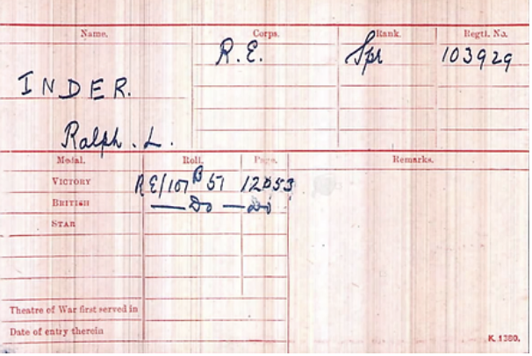 | 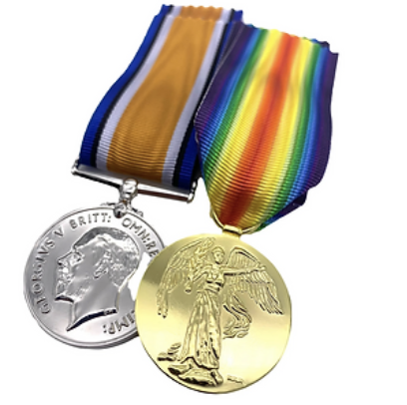

1920-1926
After the war we find him living back at home at 235 King Street, Hammersmith from about 1920 until 1926. This is a huge house wedged between two schools in Hammersmith. I expect his father had his dental surgery there. It was here that he would have started exploring what to do with the rest of his life. But he also attended wild parties - this was the swinging 20s and life after the end of the war was all about trying to get the most out of life.
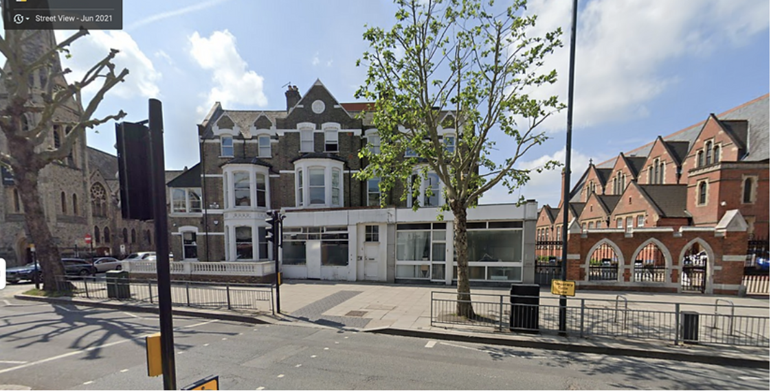

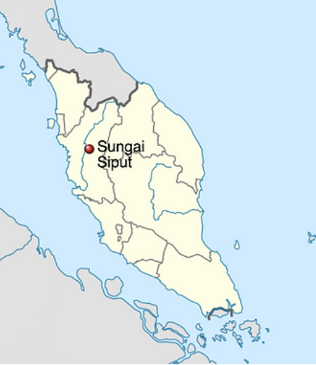 | 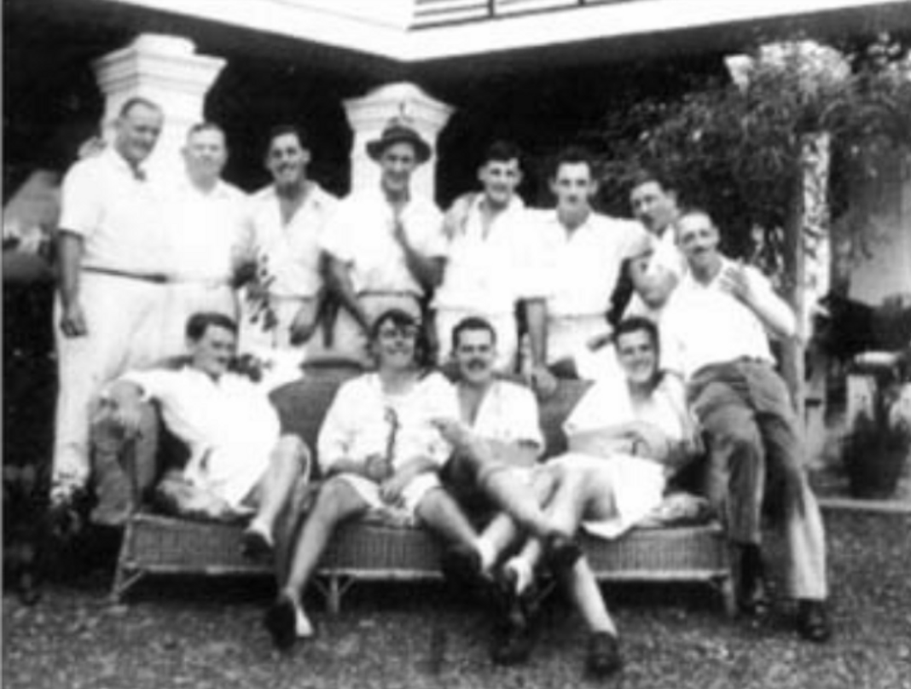

"I do not know whose idea it was to smuggle a Malay girl into his bedroom, although my friends can make a shrewd guess. Anyway, halfway through the evening, we persuaded Inder to go into his bedroom. He returned about half an hour later with a satisfied smirk to his face. No one said a word; he merely cut for the next hand and we went on playing.”
In the late afternoon he listened to the workers complaints (they were called coolies). Often he didn’t finish work till 7pm. It would have taken Ralph six months to learn the basic skills of being a rubber planter, but he also had to learn the Tamil and Malay languages. Life was tough for Ralph, as it is for anyone moving to the tropics. Boris explained that he “was bothered by mosquitoes at first, and later by flying ants and stink bugs. After a dry spell the ants would fly out of the ground and make for the nearest light, so that the room would soon become ankle deep with their corpses. Stink bugs, the shape of ladybirds but larger, would drop into one’s drink and would taste quite abominable, quite apart from the smell. Other than the mosquito nets around the beds, the ﻿Sungei Plentong bungalow was not mosquito-proofed. In addition to all the flying bugs, the ceilings were the playground for little lizards called cicak (pronounced ‘cheechah’). They are attractive little creatures whose favourite pastimes, when not devouring mosquitoes and other insects, are ensuring the survival of the species, and defecating. They also have the disturbing habit of shedding their tail when frightened.” I can so empathize with Boris – this is what Pamela and I experienced when we moved moved to Numbulwar in the Northern Territory in 1984 – one of Australia’s most remote Aboriginal communities.
Doris Howard
Either before he went to Malaya, or on one of his trips back home, Ralph met Doris Howard. Doris was christened at St Peter’s church Coventry 3 Jun 1906. She was the daughter of Frederick and Edith Emily Howard (nee) of 5A Upper Well Street, Coventry. Doris’s dad was a fellmongers manager, as was his dad before him. A fellmonger is a dealer in hides or skins, particularly sheepskins. He was also a cattle dealer (1901). No idea where Doris is until 1935 when we see that banns were read at St Andrews church Sudbury, near Harrow on July 14, 21st and 28th for her upcoming marriage to Ralph. She does give her address as the parish of St John’s in West Wickham, near Croydon, Surrey. They must have married straight after the banns were read, because within a week, they were both on board the SS Rajputana bound for Penang travelling second class. This ship is famous because in 1931 Ghandi was a passenger. You can see him and the ship in this YouTube video. The Rajputana was torpedoed 13 April 1941.
It’s hard to find information about their life-style but the 1952 film, “the Planters wife” would be a good start. I haven’t found a copy of it. “The setting is Malaya in the 50’s, still a British colonial outpost, but on the verge of independence and a new Malaya. The major industry is rubber, and the majority of this control still lies with the British. Jim Frazer (Jack Hawkins) and his wife Liz (Claudette Colbert) have built a successful rubber plantation business. Liz is dissatisfied with her lifestyle and resents having to move from her social circle following her marriage. There are bigger issues at stake however, when their lives come under threat from Malay bandits, intent on usurping British rule. Fearing for his son’s safety, Jim organizes for his wife and son to return to England. Liz misinterprets her husband’s intentions for their departure and vows never to return to Malaya. She is not given the opportunity to leave however, as a surprise attack forces the family into a battle for survival. Cast includes Anthony Steel, Jeremey Spenser and Ram Gopal.”
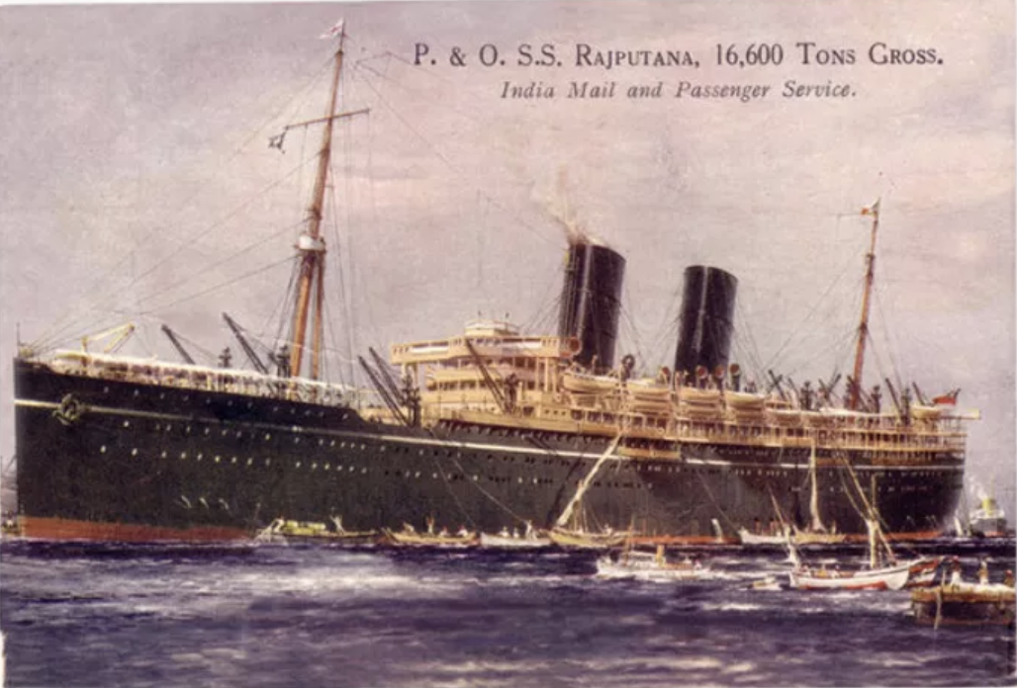
The end of an era and dark times
But dark clouds were gathering and in 1939 England was at war with Germany. The planters could have returned home, but thought that they could help the war effort better by the continued export of rubber. But they all joined the Johore Volunteer Force, which was formed in 1934. Boris was number 9 to sign on. Ralph joined in 1934 and his number was 897.
There is an article about the training that they underwent in the Straits Times Nov 1940. Ralph isn’t mentioned but then they have cut off some of the people’s names in the photo.
​Way out in the Far East, the war must have seemed a long way off, until the Japanese bombed Pearl Harbour. Then it was on their doorstep.
As the Japs approached Singapore. it was calamity on the Island. Everyone wanted to getaway.
Ralph took Doris down to Singapore and managed to get her a place on the ship the Duchess of Bedford.The transport ship Wakefield (AP-21), waiting to embark passengers, was damaged by a bomb, as were British transports (ex-passenger liners) Duchess of Bedford and Empress of Japan and the freighter Madura. Transport West Point (AP-23) was straddled and showered with fragments, but suffered no damage. She provides medical assistance to Wakefield. Both U.S. transports subsequently embarked passengers that included dockyard workers from Singapore and their families, in addition to Royal Navy officers and enlisted men and a small RAF contingent. Some ships left but the Duchess of Bedford was left behind. She had received a bomb through one of the open hatches, but although the hold was flooded. The ship finally managed to leave, avoided being captured by the ships of the Japanese Navy that were arriving in the area and finally reached Liverpool on 4 April 1942. The Duchess of Bedford, called "the most bombed ship still afloat", was a very lucky ship. During World War II, she sank a U-boat, damaged another, was shot at and bombed on a number of occasions, and once struck an iceberg without sustaining damage.
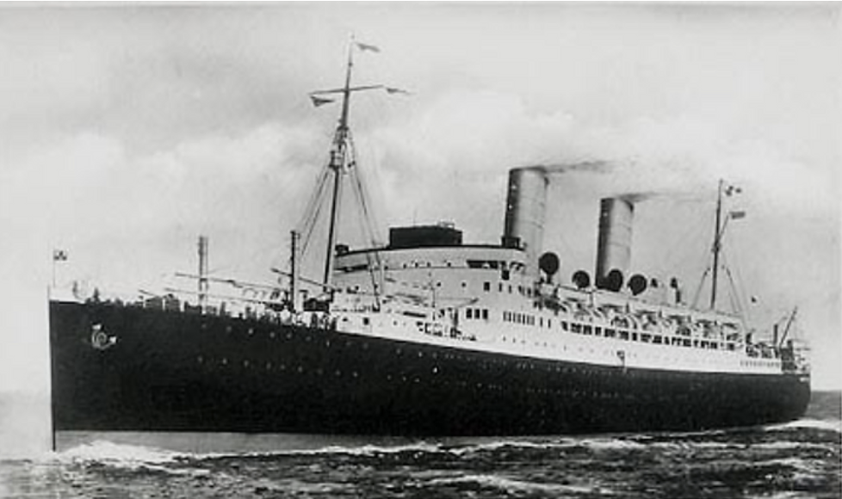
SS Duchess of Bedford that Doris managed to escape from Singapore on
Singapore fell to the Japanese 15 Feb 1942. When the Japanese arrived in Singapore, Ralph was rounded up and spent 3 years in appalling conditions. He was captured 15 Feb 1942 and was released 2 Sep 1945, spending the whole time in Thailand POW camps and he worked on the death railway.
The pic below is a Japanese index card for allied prisoners of war and internees. For more information on the life of prisoners see Wikipedia. There is another really good website about the trials and tribulations of a Johore Volunteer Engineer.
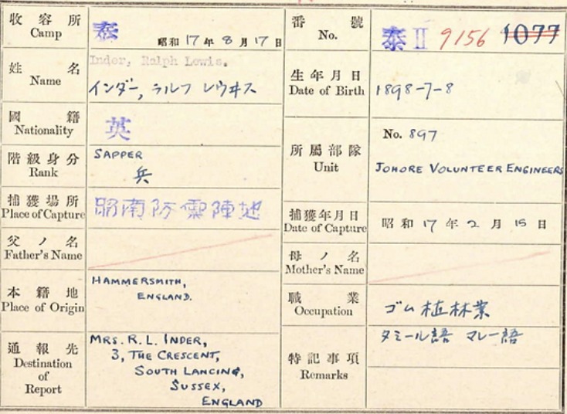
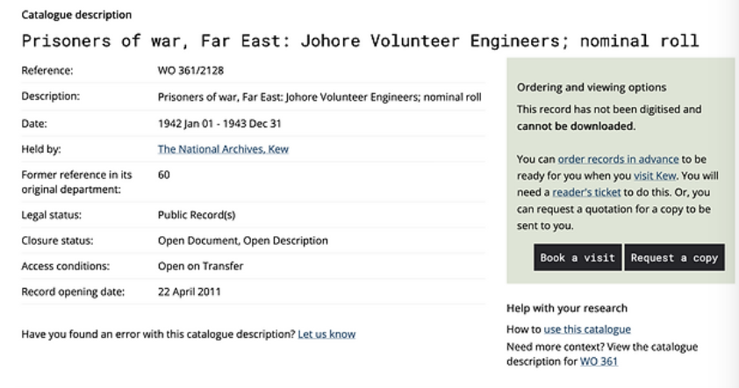
There is a website called the Malayan Volunteer Forces gives us this information and it would apply to Ralph: “The Volunteers were of enormous help to the thousands of captured British Forces, especially those who had only been in the Far East for a matter of weeks before capture. They knew and understood the local languages and the people, particularly those who remained loyal to the British and wanted to help them. They were acclimatised to the conditions, which must have been difficult to adjust to for the newly arrived troops - most of whom had received no training in jungle warfare. They understood the prevalent diseases such as Malaria and Dengue Fever, how best to avoid them, and the medicines that were needed to control them. They were able to barter with the local traders for food and medicine, and to set up a system of 'listening posts' for information, especially in the early months of imprisonment.”
“Even in Thailand, while building the infamous Burma/Siam Railway, some of the Volunteers were able to speak Thai and make contact with the local Thai / Thai Chinese population, to get the extra food and medicines so urgently needed by the starving and desperately ill prisoners of war.”
During the time that Ralph was a POW, Doris was living in England, not knowing if her husband was alive or dead. She lived at 8 The Crescent Lancing. This little semi-detached bungalow was identical to number 3 where she had lived before the war.
Released POW and back to England 1946
Finally Ralph did return from Singapore in an emaciated and in poor condition. He had lived through appalling conditions and the fact that he had survived by itself was a miracle. He tried to get a job, but unemployment was very high and the country was bankrupted and having spent 10 years in the tropics he couldn’t stand the cold weather, and he dreamed about his planter's life. Furthermore the Malayan Voluteer Forces webpage states “When the Volunteers and other FEPOWs were finally repatriated to Britain late in 1945, and returned home to their loved ones, Europe had been at peace for over 4 months. There was a sense of purpose in the country, and a great determination to put the memories of the last six years of war behind them, so that people could get on with their lives and look forward to a brighter future.”
“It was into this atmosphere of optimism that the FEPOWs, including the Volunteers, returned. How devastating it must have been for them that no-one wanted to know about their ordeals and experiences or could understand what they had been through. Indeed, most people in this country had been (and still are) totally unaware of the harrowing time the FEPOWs had endured - the murders, the tortures, the deprivations, the sheer and utter brutality of an alien foe - and they didn't want to start hearing about it. In fact, the general impression was that the FEPOWs had been languishing in some kind of luxurious holiday camp in the Far East, while their kith and kin had been enduring the horrors of the Blitz on the Home Front, and the D-Day Landings in Europe”
​
The Imperial War Office in London has file entitled private papers of RL Inder which has extracts from his diary covering his experiences at the time of the fall of Singapore (Feb 942) and as a prisoner of war during the railway journal from Singapore to Thailand and then in Banpong camp.
Ralph was very happy to be reunited with Doris, but very unhappy to be in England so, as soon as he could, he booked passage and returned to the Far East.
Ralph sails back to Malaya 1946
On 26 Feb 1946 he sailed on board the Nieuw Holland of the Nederland line bound for Batavia. The ship departed Glasgow 26 Feb 1946. Ralph is on board but not Doris. He is listed as a rubber planter and his English address is C/- Mrs Elliott 74 Gloucester Court, Kew. The whole page is filled with unaccompanied men and they are almost all rubber planters.
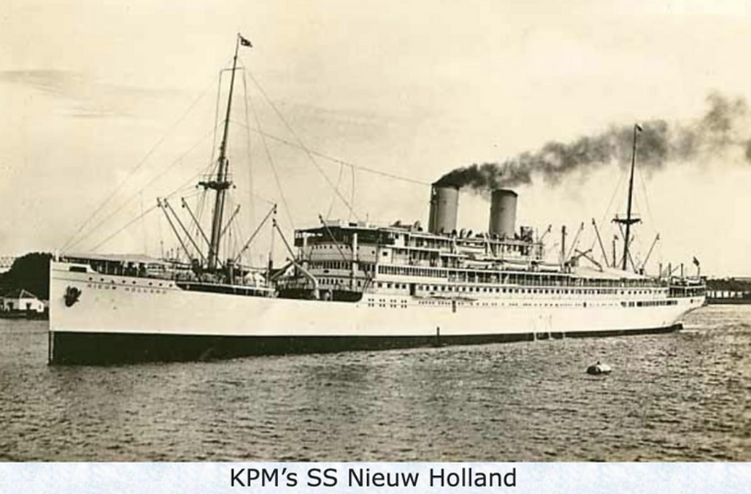
Ralph secured the family home and then let Doris know that it was OK for her to go out, which she did and she left England on 25 May 1946 bound for Batavia, Java on board the Nederland line’s MS Bloemefontein. From the passenger list it looks like most of the passengers were women. All returning to the home they knew before the war. Only 5 years have passed, but the situation in Malaya has changed for ever. The life they knew was about to come to a bloody end.
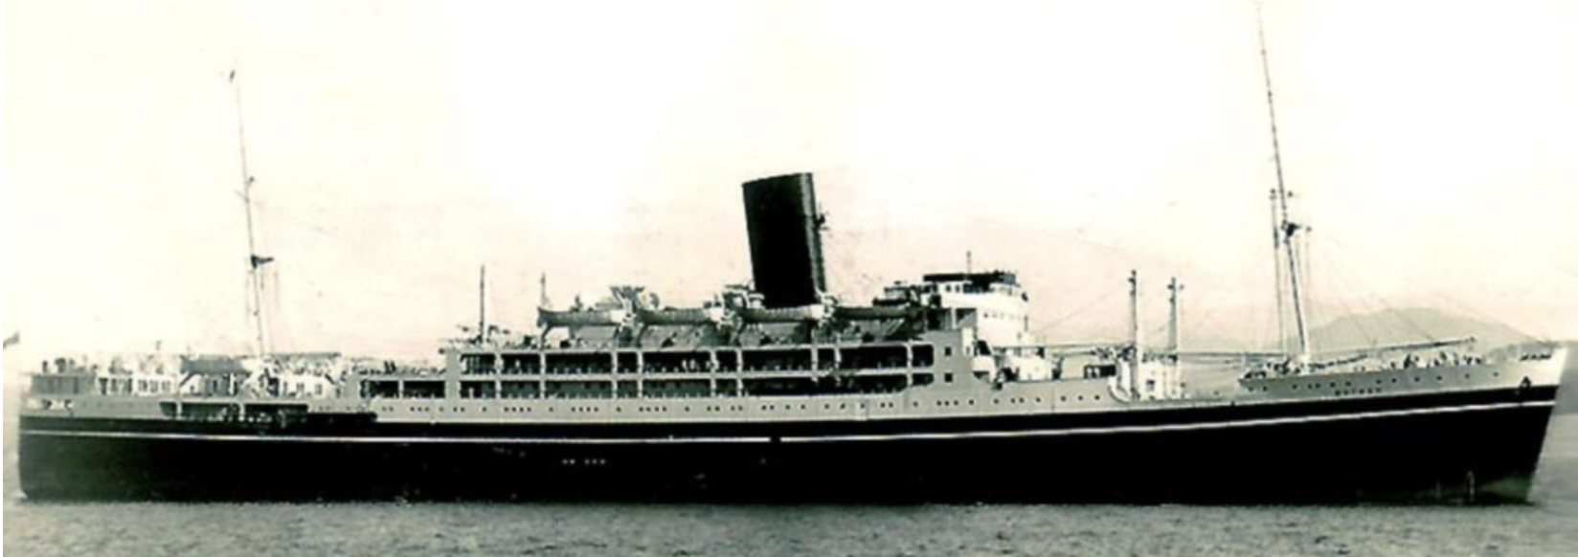
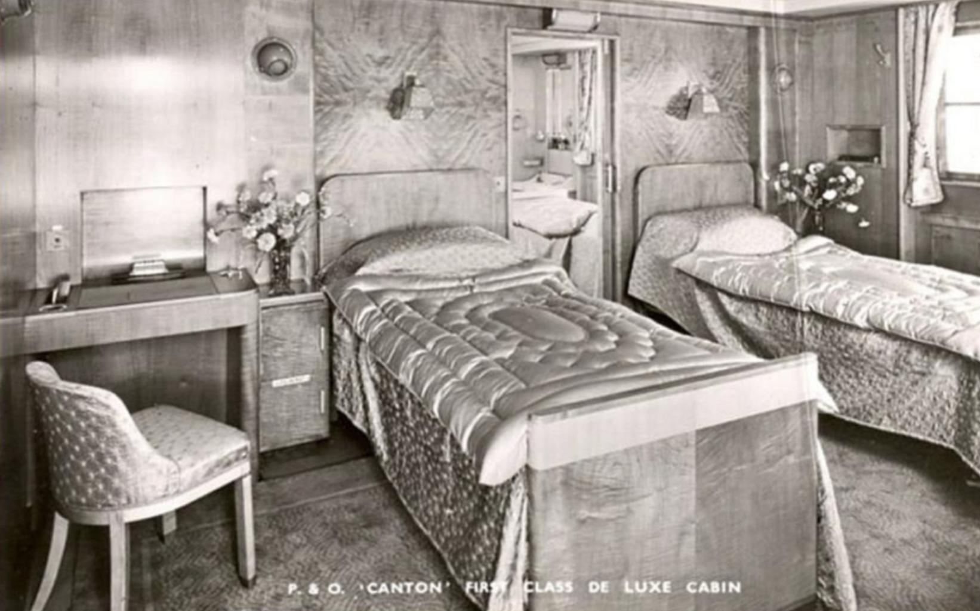
Ralph and Doris settled back into the life of a planter at the Dovenby estate in Johore. But life could never go back to the way that it had been. It was at this time that the Malayan Crisis started. The Malayan Emergency, also known as the Anti–British National Liberation War was a guerrilla war fought in British Malaya between communist pro-independence fighters of the Malayan National Liberation Army against the military forces of the British Empire and Commonwealth (Wikipedia). Ralph decided his skills and experience in WW2 could come in very handy, so he applied to join the Constabulary. Before starting his new job and knowing that it was going to be dangerous, he and Doris decided to have a holiday and in 1949, enjoyed a luxurious cruise, travelling first class on the P&O liner the SS Canton. They arrived into the Port of London on 16 May 1949, giving their address as 23 Southway, Raynes Park. They had a wonderful holiday in England, visiting family and catching up on family matters. But all too soon it was time to head back to Malaya. They departed Southampton 9 March 1950 heading for Djakarta on board the MS Willem Ruys, which was a brand-new ship built in 1947. Note: In 1965 the Willem Ruys was sold to an Italian cruise line and renamed the Achille Lauro. She evacuated the British families from Aden and was one of the last ships to pass through the Suez Canal before the Six day war. On 7 Oct 1985 the Palestine Liberation Organisation hijacked the ship off the coast of Egypt. They demanded the release of 50 Palestinian prisoners in Israeli prisons and brutally murdered a disabled Jewish-American prisoner and threw his body overboard. In 1994 she caught fire off the coast of Somalia and sank.
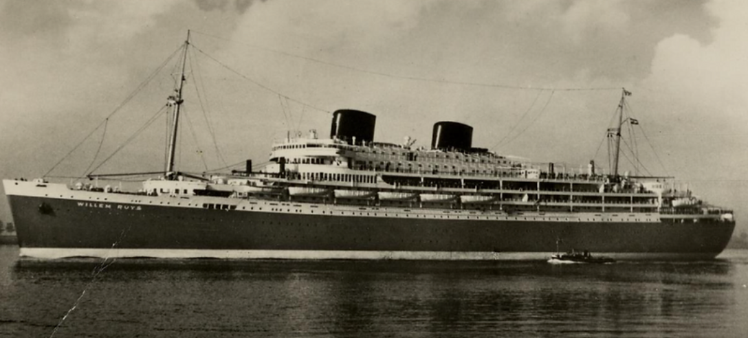

Malayan Special Constabulary
Meanwhile the planters and the British government that looked after Malaysia created a special constabulary to protect the people and the planters from the communist guerillas. The wages were much better than a planter was getting - 150 shillings and a death gratuity of $700. Ralph signed up and with his language skills, jungle experience and military training, he was appointed as an inspector. 30,000 Malays also volunteered. For information about life at this time, you can’t go past the Malayan Emergency on youtube.
The constabulary were trained by members of the British Palestine police who had been withdrawn from the now free state of Israel. The Malayan volunteer police units had to guard the mines and rubber plantations.
​
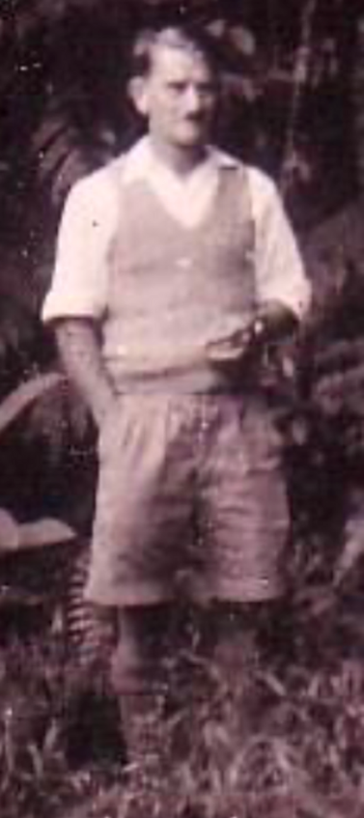
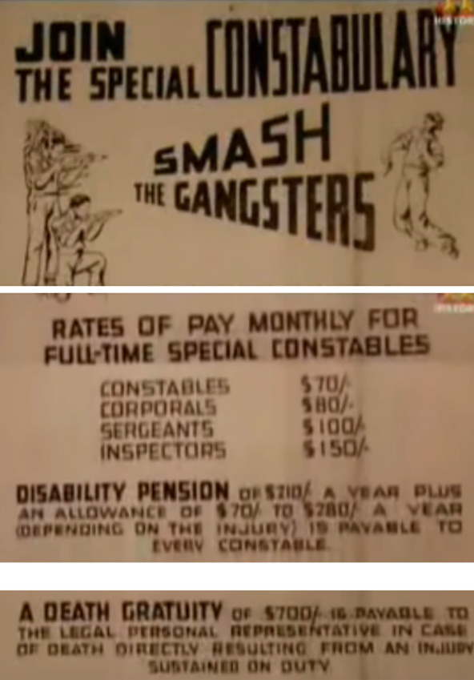
“After I left Kedah in April 1934 I saw little of Ralph Inder until he turned up at Sungei Siput in 1950. Shortly after breakfast one day in early July, I was standing talking to Louis Denholm, who was to take over from me on Kamuming when I went on leave, when we heard a sudden burst of automatic gunfire ntermingled with spasmodic rifle fire. This obviously came from the Dovenby Estate which we were overlooking from our hillside. I remember saying to Louis ‘Here we are, going quietly about our business, when over there one’s best friend is being murdered.’ Poor Ralph was not my best friend, but he was certainly an old friend. He died of multiple bullet wounds 24 hours later.”
“It would appear the early on that morning, communist terrorists had slashed a lot of young rubber trees on Dovenby. Ralph had gone out to investigate and the bandits were waiting for him. Ralph and his escort of two constables were outnumbered six to one, but they put up a good fight. One of the special constables was killed and the other badly wounded, and the bandits got away with their weapons.”
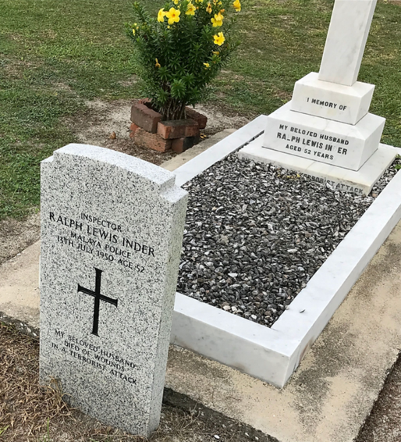
See Youtube newsreel footage 1952: https://www.youtube.com/watch?v=oAO9xqXZ6BQ and an excellent interview with Lt-General Sir Brian Horrocks about the Malayan Emergency.
Ralph was severely injured in the line of duty by terrorists. He died at Ipoh District Hospital on 13 Jul 1950 and was buried 15 July at Batu Gajah Christian Cemetery. Probate was granted 6 March 1952 to Cecil Herbert Howard, civil servant and Ernest Clifford Webster, solicitor. He was worth £599.3.8d.
Doris, widowed, returned home to England to their cottage in Worthing.

Franklin Charles Bellman
Isaac Dixon > Jane Dixon – Barnes > Fanny Jane & Henry Bellman> Franklin
Franklin Charles Bellman b 1 Jun 1874 Dulwich, Surrey. On 18 Apr 1887 he was admitted to Goodrich Road School which had opened in 1886. Reorganised to form Goodrich Primary School and Thomas Carlton Secondary School in 1951. He became a joiner and lived at 58 Milton Road, Brixton. He married Gertrude Mary Chatterley 21 Feb 1903 at St Jude, East Brixton. Her father was James Chatterley. Four years later they decided to emigrate to New Zealand and left England 30 Oct 1907 on board SS Paparoa. They travelled as steerage and settled at 4 West Road, Northland, Wellington.Built for the New Zealand Shipping Company and named after a suburb of Christchurch, the Papanui was launched in Dumbarton on 4 November 1898.2 The 6,370-ton vessel could carry 34 first class; 45 second class and 400 emigrant (steerage) class passengers and a crew of 100. We cannot know the conditions that the Bellmans experienced but Wikpedia explains that “Steerage refers to the lowest possible category of long-distance steamer travel. It was available to very poor people, usually emigrants seeking a new life in the New World, chiefly North America and Australia. In many cases these people had no financial resources and were attempting to escape destitution at home. Consequently they needed transportation at an absolute minimum cost. In many cases they provided their own bedding and food. Steerage was very cramped and there was hardly any room for fresh air to get there. Many people died in steerage.”
“ She was a very unlucky ship - for more info about her many unlucky experiences, follow this link: https://sainthelenaisland.info/ianbrucepapanui.pdf
​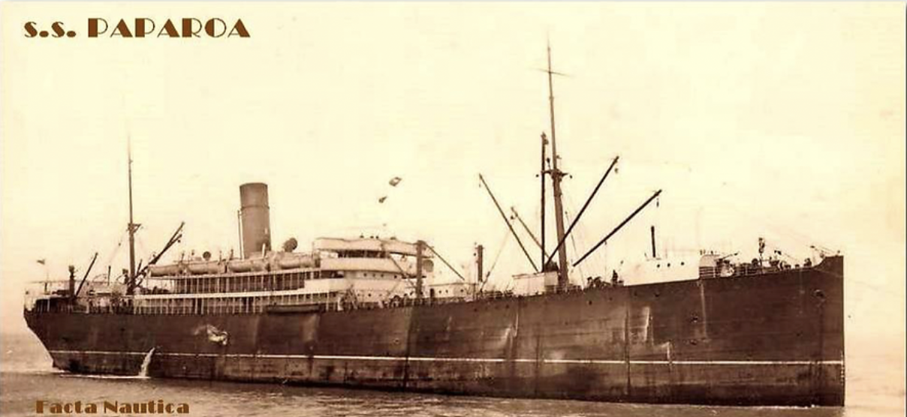
There is a model of the SS Paparoa at the Maritime Museum of Tasmania.
My thanks to Chris Lam Sam for these words: “It was October 30th 1907 when Franklin Charles and Gertrude Mary, along with their daughter, Kathleen (my great grandmother, who I affectionately called "GG" at an early age when my words were still developing!) left London, England on an 'Ocean-Going Liner' called the S.S Paparoa. Seven weeks later, and just three days before Christmas on December 22nd, the Paparoa finally dropped its anchor at its destination port of Wellington, New Zealand at 12.30pm. After a short visit from a doctor who checked all on board, they finally birthed at Queen's Wharf at 2pm”
Below: Franklin Charles, and Gertrude Mary Bellman (nee Chatterley), with their first three children. Kathleen Phyllis (7), Jessie Florence Olive (3 and a half), and Eric Franklin (19 months). The children's ages were handwritten on the back of the photo, along with the date Feb 1912. Donated by Chris Lam Sam
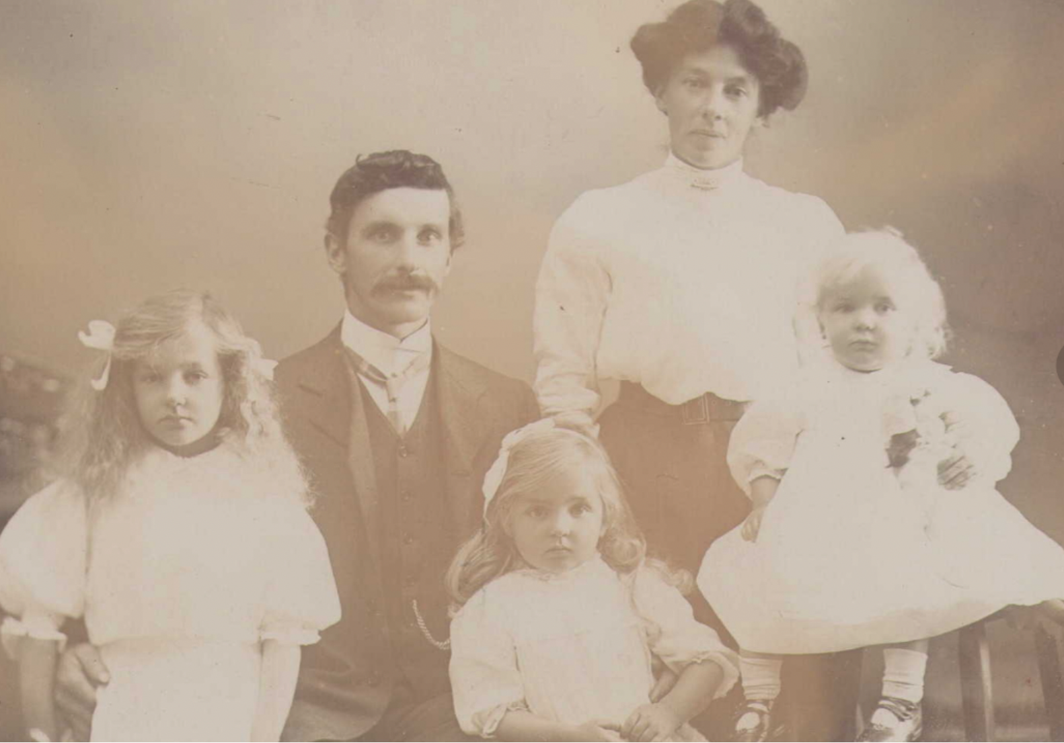

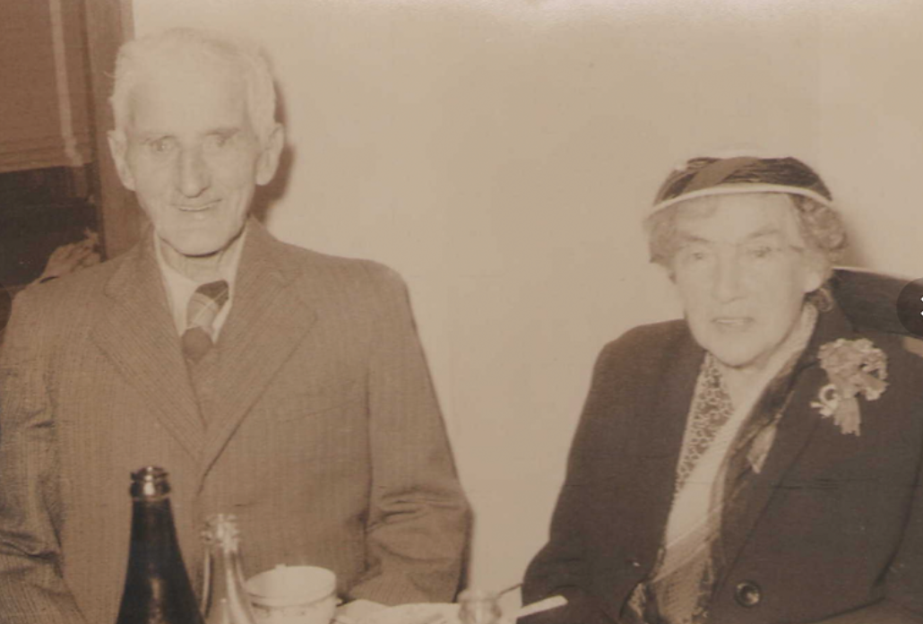 | This photo was taken at his grandson William's wedding. It was the day before he passed away in his bathroom, and therefore the last photo he had taken with his wife, Gertrude. His granddaughter, Margaret owned this photo of him and told NZSamLam this story as they viewed it together in 2013 at her home in Wellington. He was 81 years old in this picture. Donated by Chris Lam Sam

The children of Franklin and Gertrude Bellman
- Kathleen Phyllis Bellman b 22 Nov 1904 Lambeth; baptized 8 Jan 1905. She would have been a baby when the family emigrated to NZ in 1907. She married Fred Carl Jessen on 23 Apr 1928. Fred was born 3 May 1904 at Mauriceville, Masterton, Wellington, NZ, the son of William August and Christine Jessen. Fred died in 1972 at the age of 72. Fred and Kathleen had:
  - Margaret Jessen married Laurence Martin b 1927 Petone, New Zealand and d Johnsonville, Wellington NZ 201 They had three children and I know about Carol b 1954 d 1995.
- Jessie Florence Olive Bellman b 15 Jun 1908 Christchurch, NZ married Shukrullah Eskanda Moukhieber Alexander from Lebanon and had
  - Yvonne Malakai Alexander
  - Maureen Soraya Alexander
  - Ramon Alexander
  - Kay Nanette Alexander
  - David G Alexander
- Leslie Bellman b Christchurch married Gene Johnson and had issue
  - Raymond Bellman
  - George Bellman
- Leonard Bellman b Christchurch married Dora

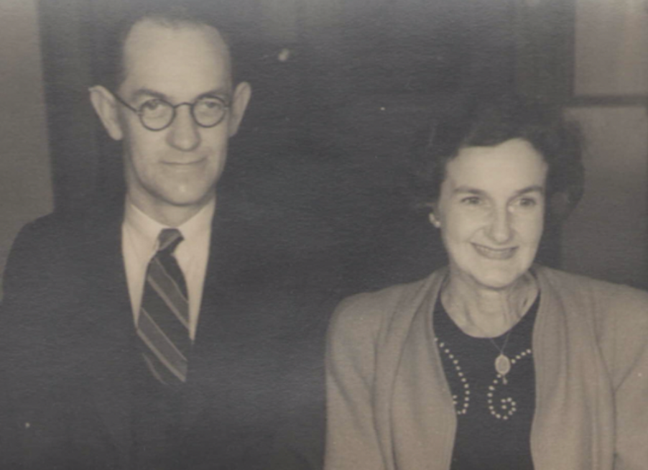  The photo of Carl above) was donated by Chris Lam Sam, as was the photo of Carl and his wife Kathleen (left). | 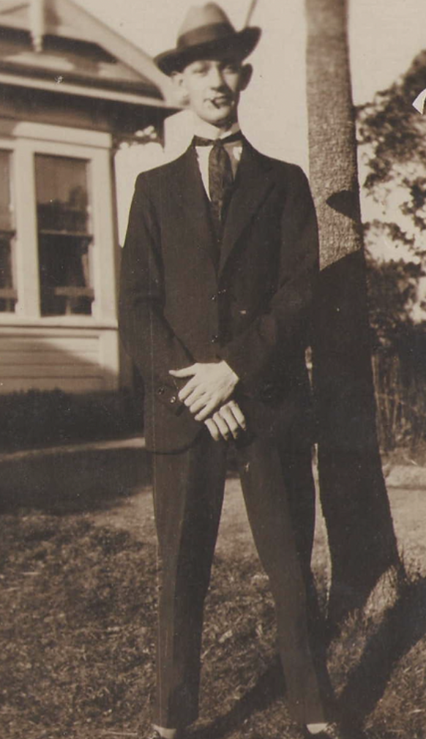

Chapter ? Gen ?: Kathleen Phyllis Jessen (nee Bellman)
Isaac Dixon > Jane Dixon – Barnes > Fanny Jane & Henry Bellman> Franklin & Gertrude Bellman > Kathleen
Kathleen Phyllis Bellman b 22 Nov 1904 Lambeth; baptized 8 Jan 1905. She would have been a baby when the family emigrated to NZ in 1907. She married Fred Carl Jessen on 23 Apr 1928. Fred was born 3 May 1904 at Mauriceville, Masterton, Wellington, NZ, the son of William August and Christine Jessen. Fred died in 1972 at the age of 72. Fred and Kathleen had:
- Margaret Jessen married Laurence Martin b 1927 Petone, New Zealand and d Johnsonville, Wellington NZ. Children:
  - Carol Anne Martin b 1954 d 1995. Married Peter Poe Lam Sam b 1953. Issue:
    - Chris LamSam n 1981

Chapter ? Gen ?: Chris Lam Sam
Isaac Dixon > Jane Dixon – Barnes > Fanny Jane & Henry Bellman> Franklin & Gertrude Bellman > Kathleen & Fred Jesson > Margaret & Laurence Martin > Carol & Peter Poe Lam Sam > Chris

Chris Lam Sam b 1981 married Kate Alecia Hughes b 1980. Chris is famous throughout New Zealand as a children's entertainer. This is from his website: Chris is a popular children’s entertainer, a published picture book author with London’s TATE Museums, and the NZ Symphony Orchestra says he is one of the best Master of Ceremonies they have ever worked with. Over the last 21 years he has performed live concerts for more than 2 million people, and worked with some of the best loved brands and musicians in Aotearoa and the world. He has written an album of children’s songs for Plunket New Zealand, he has performed with Sir Dave Dobbyn and two-time GRAMMY Award winner Kimbra, and he has MC’d events for The Royal NZ Ballet, World of Wearable Art, and The Muppets. Chris is a unique performer who excels in working with two very different audiences — children and adults. “For anyone confused about how I balance that, it works the same way it works for Kermit the Frog,” says Chris. ”And I’ve worked with him!” Chris has his own website here: https://www.chrislamsam.com/
Chris is also a published author - he wrote the children's book Inspector Brunswick: the Case of the Missing Eyebrow. Available at Amazon.
In May 2022 Chris won the Best Children’s Music Video award at the NZ Children’s Music Awards. The NZ Children’s Music Awards are an annual presentation celebrating music written for Kiwi kids. Chris's song was called Song About Nothing.
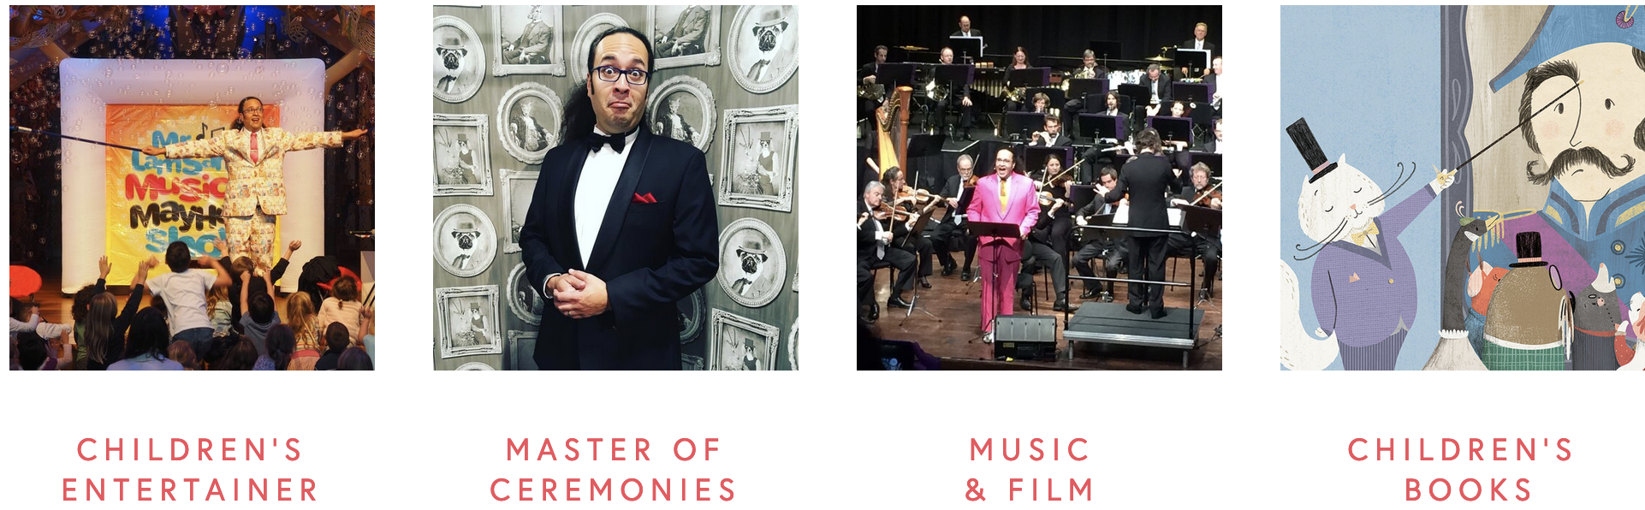
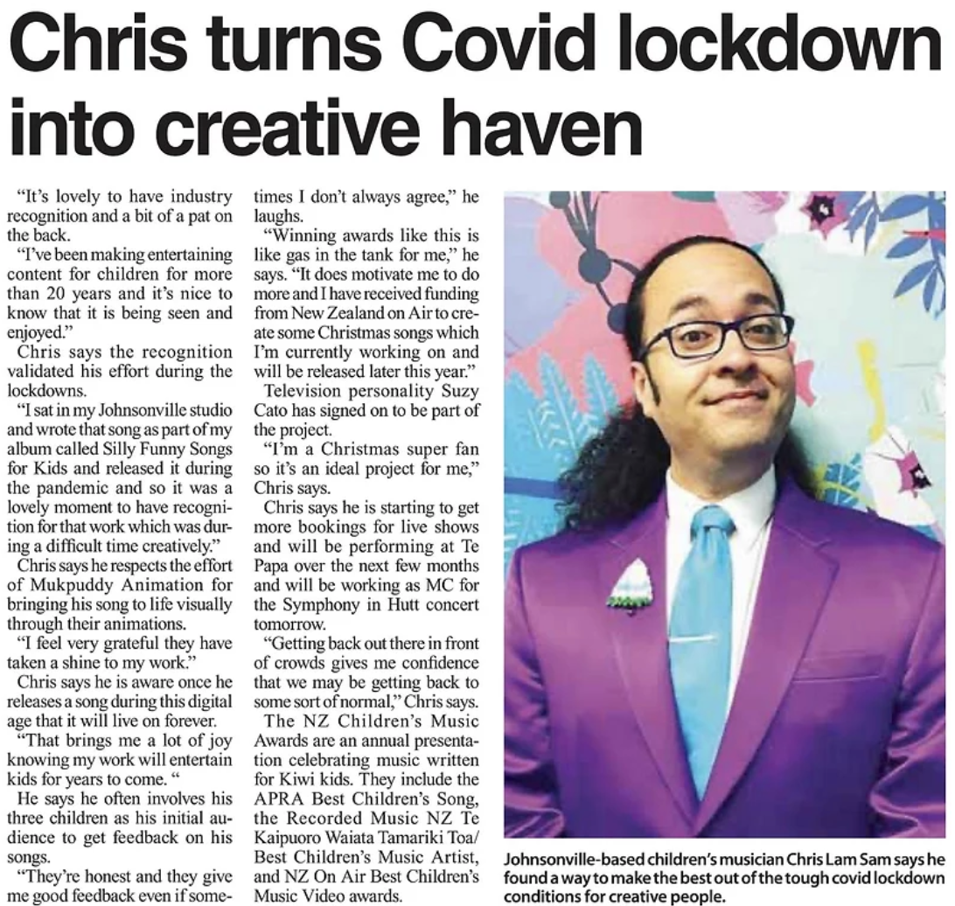
Newspaper article 26 May 2022

After completing a Bachelor of Music majoring in composition at the University of Waikato in 2002, he went on to earn a Graduate Diploma in Primary Teaching at the Waikato School of Education in 2005. In 2008 he combined his qualifications to begin working as a full-time musical entertainer for children.
A generation of New Zealanders now recognise him as a member of The Funky Monkeys, a musical children’s supergroup he and his friends began in 2003. Together they performed over 900 live shows to 1.7 million people, produced seven albums, two DVD’s, won the inaugural APRA NZ Best Children’s Music Video Award in 2008, and co-produced the album that won Waikato Plunket the Prime Minister’s Award For Innovation in 2010.
Chris has continued long associations with a number of productions for children; he has been Musical Director for the Kids For Kids choir concerts since 2009, he has performed the Sailor Asthma Show over 600 times for the Asthma & Respiratory Foundation of NZ since 2013, and he performed regularly as the Animateur for the New Zealand Symphony Orchestra’s education concerts since 2016.
In early 2017, Lam Sam flew to London to release his first co-authored children’s book with kiwi illustrator, Angela Keoghan and their publisher, the TATE Museum. Their book Inspector Brunswick: Case Of The Missing Eyebrow went on to win the 2018 Storylines Notable Book Award alongside co-winners Dame Lynley Dodd, DNZM, and Dame Joy Cowley, ONZ.
Since 2019 he has successfully been awarded $30,000 in funding from NZ On Air, enabling him to launch three different projects including his first independent children’s music single and video Let’s Love Our Sea as part of a musical collaboration with award-winning underwater photographer, Steve Hathaway from Young Ocean Explorers.
In 2020 he received a $25,000 grant from Creative NZ to produce is first independent album of Silly Funny Songs For Kids. Six months later the album was a finalist for an Aotearoa Music Award - the Recorded Music NZ Te Kaipuoro Waiata Tamariki Toa / Best Children’s Music Artist.
In 2022 he won the NZ On Air ‘Best Children’s Music Video’ Award for his ‘Song About Nothing’ music video, produced by Mukpuddy Animation.
As an active advocate for the NZ children’s music industry, Lam Sam was a founding board member of the Kiwi Kids Music Trust, the charitable arm of Kiwi Kids Music Collective. He served as Secretary for a year before being voted in as Chair, replacing well-known children’s TV presenter and song writer, Suzy Cato until Feb 2021. From 2014-2019 he was also Chair of The Goodtime Foundation, a charitable trust working to provide free music lessons, instruments, and life skills mentoring for underprivileged school children.
Lam Sam’s musical entertainment work in the corporate and comedy spheres has seen him performing as the occasional ‘lone keyboardist’ for the Improv Bandits since 2001. He performed at their 20th Anniversary Show featuring Who’s Line Is It Anyway? guest star, Colin Mochrie. Lam Sam continues to perform one-off character based musical shows with seasoned actor, opera singer, and improvisor, Greg Ward. Lam Sam was also keyboardist for popular swing-funk band Late 80’s Mercedes from 2013-2018.
In his time as a musical performer, he has toured two different children’s shows the full-length of New Zealand, and has also performed shows in Australia, Denmark, England, and Hawaii.
Chris currently lives in Wellington with his wife and three sons, and continues to tour and perform original music for young families in his independent show, Mr. Lam Sam’s Musical Mayhem Show.

Letter from Victoria & Albert Museum in 2016
Letter from Penny Duggan; Bexley Historical Society 2016
Source Family Search
Research from Julia of Acorn Family History Research
Romney Marsh: Environmental Change and Human Occupation in a Coastal Lowland; Eddison, Gardner and Long
Romney Marsh: Environmental Change and Human Occupation in a Coastal Lowland; Eddison, Gardner and Long
Wikipedia
Memorials of old Kent p 275 ebook.
Times of London May 1816
Times of London Aug 1816
The Baptist reporter 1843
Baptist Magazine 1843
The Manchester Chronicle of 22 July 1843
< https://history.wiltshire.gov.uk/community/getcom2.php?id=225>
Army Medical Board dated 16 Aug 1916
Wikipedia
Malaysian Spymaster: Memoirs of a rubber planter, bandit fighter and spy
Malaysian Spymaster: Memoirs of a rubber planter, bandit fighter and spy
https://www.acmi.net.au/works/87398--the-planters-wife-outpost-in-malaya/.
Malaysian Spymaster: Memoirs of a rubber planter, bandit fighter and spy
Wikipedia
LamSam Ancestry site
https://www.chrislamsam.com/about

